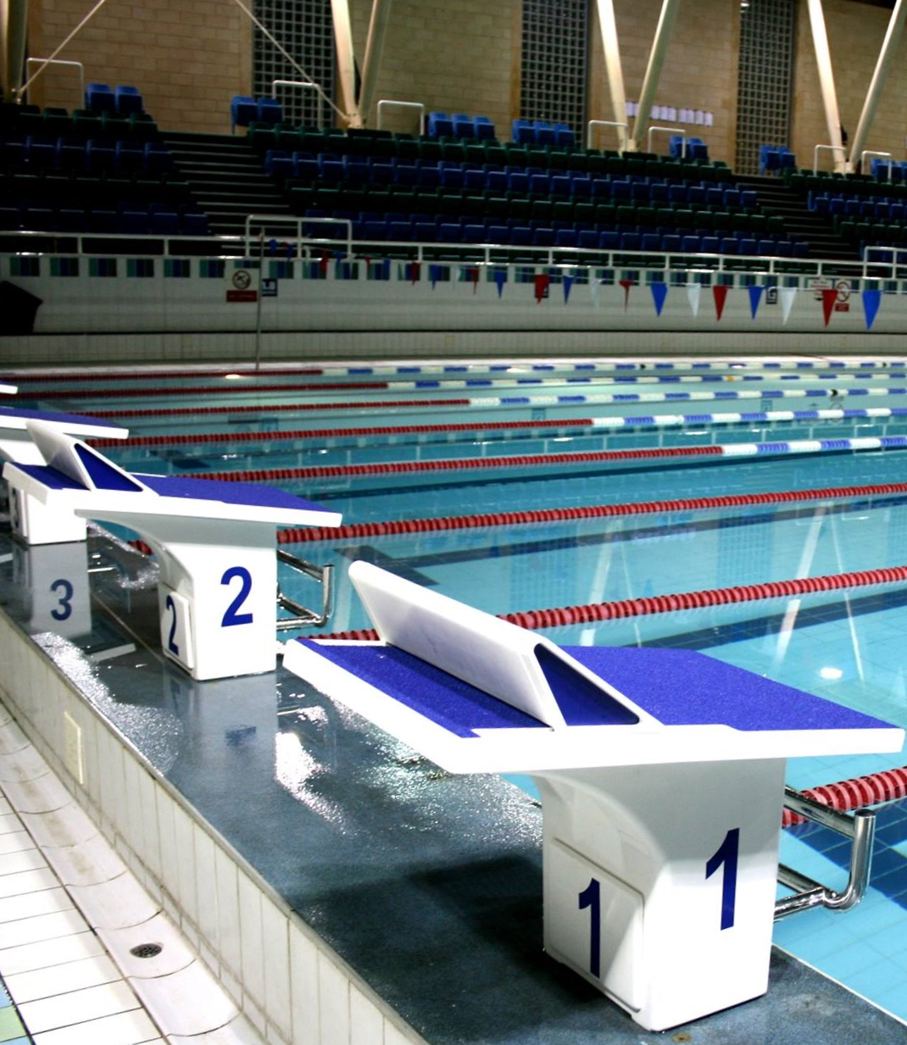
City of Cambridge Swimming Club
Parkside Swimming Pools, Cambridge.
Cambridge Spring
Open 2019
Level 3 No. 3ER190464
29th, 30th & 31st March, 2019

City of Cambridge Swimming Club

Cambridge Spring Open 2019

(License Number: 3ER190464)

Friday 29th, Saturday 30th and Sunday 31st March 2019

Affiliated to the Swim England East Region
Under Swim England Regulations and Technical Rules of Racing

Venue: Parkside Swimming Pool, Gonville Place, Cambridge, CB1 1LY

Pool: 8 Lane, 25m Pool, Electronic Timing, Olympic standard blocks.

Age Groups: 9, 10, 11, 12, 13, 14, 15, 16 and over. For event restrictions see qualifying times table.

Awards: Heat Declared Winners with awards to top three in each age group.

Events: 50m, 100m and 200m all strokes, 400m Freestyle and 200m and 400m IM.

Fees: Race Entry Fee: £6.00 per event
Spectator Entry £3.00 per session or £5.00 all day.

Entries to: Meets Secretary,
City of Cambridge Swimming Club, Parkside Pools, Gonville Place, Cambridge, CB1 1LY

Closing Date for Entries: 12.00 Midnight on 15th February, 2019.

Enquiries can be e-mailed to meets@cocsc.org.uk

Meet Programme

Session 1
Friday 29th March
Warm-up 6.15pm
Start 7.15pm
101  102  103  104  105  106 |  | 50m Butterfly  50m Butterfly  50m Backstroke  50m Backstroke  50m Breaststroke  50m Breaststroke |  |  | Female  Male  Female  Male  Female  Male
Session 2  Saturday 30th March  Warm-up 12pm  Start 1pm |  |  | Session 4  Sunday 31st March  Warm-up 11am  Start 12pm
201  202  203  204  205  206 | 400m Freestyle  100m Breaststroke  100m Breaststroke  200m Butterfly  200m Butterfly  50m Freestyle | Male  Female  Male  Female  Male  Female | 401  402  403  404  405  406 | 400m Freestyle  100m Butterfly  100m Butterfly  200m Breaststroke  200m Breaststroke  50m Freestyle |  | Female  Male  Female  Male  Female  Male
Session 3  Saturday 30th March  Warm-up tbc  Start tbc |  |  | Session 5  Sunday 31st March  Warm-up tbc  Start tbc
301  302  303  304  305  306 | 400m IM  200m IM  100m Freestyle  100m Freestyle  200m Backstroke  200m Backstroke | Female  Male  Female  Male  Female  Male | 501  502  503  504  505  506 | 400m IM  200m IM  100m Backstroke  100m Backstroke  200m Freestyle  200m Freestyle |  | Male  Female  Male  Female  Male  Female
Timings noted above are indicative, and may alter slightly.
Final timings will be confirmed shortly before the meet.

Meet Rules and Information

- This Competition is licensed by Swim England and will be held under Swim England Regulations and Technical Rules.
- Entrants must be Swim England registered Category 2, belong to an affiliated club and enter in the name of one club only.
- All entry times must meet the qualifying times and criteria stated on the qualifying times table.
- Swimmers in possession of an Swim England Certificate of Swimming Disability or whose Swim England membership record details a disability sport class are welcome to enter the competition with a time slower than the lower limit standard. An entry time must be provided.
- This is a first come first served meet. The promoter reserves the right to limit entries. Competitors may be rejected if the meet is oversubscribed in order to meet license time guidelines.
- All entries of three or more swimmers must be made electronically. Electronic SPORTSYSTEMS Entry Manager files are available on request by e-mail to meets@cocsc.org.uk or from the club website at www.cocsc.org.uk. There will be an administration charge of £20 for group entries not submitted electronically.
- Entry forms and payment must be received by the Promoters before midnight on 15th February 2019 and must be fully and correctly completed, or else they may be rejected.
- The list of accepted and rejected entries will be published/available for download on the club website (www.cocsc.org.uk) approximately two weeks prior to the competition. It is the competing club/swimmer’s responsibility to check this list for accuracy and advise immediately of any mistakes or changes that are required.
- Competitors’ ages shall be as at 31st March 2019.
- Swimmers must withdraw from events that they no longer wish to swim. All swimmers informed of having accepted entries will be deemed as competing unless they have informed the promoter that they do not wish to swim.
- Withdrawals should be made via e-mail to meets@cocsc.org.uk by midnight on Wednesday 27th March, 2019 stating the event number, full name, date of birth, entry time and club.
- Any on the day withdrawals must be made by coaches or the club representative one hour prior to the start of the first event in each session. Withdrawal forms will be included in the coach packs, completed forms should be given to the meet promotor or volunteer co-ordinator via the computer desk.
- Refunds are not available for withdrawals, other than for medical reasons. Any competitor that withdraws on medical grounds will not be able to participate in any events for the remainder of that session.
- The pool length is 25 metres, 8 lanes with anti-wave ropes and electronic timing and the depth of the pool is 1.2m at the shallow end and 1.8m at the deep end.
- Backstroke start devices may be used.
- Any swimmer not reporting to the marshalling area in a timely manner, normally one event in advance of their own, may be deemed to have withdrawn from that event.
- All events will be seeded on submitted times and all heats will be spearheaded. The first three swimmers in each event in each age group will receive awards.
- Coaches/Team Managers will be allowed on poolside if wearing a pre-purchased pass. Coaches and Team Managers must be club trained personnel and clubs are asked to maintain the recommended ratio of helpers to swimmers. Untrained parents without DBS clearance are not allowed poolside.
- Over the top starts may be used at the referees’ discretion.
- The promoters do not accept responsibility for any property.
- For Health and Safety reasons only small rucksack bags will be allowed poolside. Lockers are available (refundable £1 coin required). Pool staff will remove any large obtrusive bags.
- Limited seating poolside will be available for Coaches and swimmers. No additional seating is permitted.
- No person will be allowed on poolside without a pass.
- There will be no glass items allowed on poolside.
- The promoters reserve the right to refuse admission to any competitor, participant, coach or spectator.
- By submitting and accepting entries to the meet, consent is hereby given, as required by the Data Protection Act 2018, to the holding of personal information on computer. Personal data handled such as name, club, recorded and entered times may be made public during or after the meet.
- Charges as follows: Race Entry Fees £6.00 per event, Spectator fees £3.00 per session or £5.00 per day, Programmes £3.00, Coach/Team Manager Passes £12.00 per day (including lunch and a programme), except Friday which is free of charge.
- In accordance with Swim England Child Safety Procedures and Policies all parents or carers of swimmers under the age of 18 who wish to take photographic or video images are requested to focus on their own child as much as reasonably possible and to avoid including other children in those images, particularly if those images are being shared with family and friends through social media platforms. Should you have any concerns about photography or filming at this event then please bring them to the attention of the Meet Promoter, Catherine Pearson.
- Warm up protocol: Strictly no diving during any warm-up sessions, except in the designated sprint lanes, odd lanes will swim clockwise (1, 3, 5, 7) even lanes (2, 4, 6, 8) will swim counter clockwise. All swimmers must leave the water by the side of the pool and not over the timing pads. Coaches must manage the lanes their swimmers are using during the warm up sessions. Guidance will be given by the meet announcer.
- Any matter not covered by these conditions will be determined by the Promoter and Referee, subject to Swim England Regulations and Technical Rules of Racing.

Para Swimming Conditions

The conditions outlined above shall apply to all para swimmers except where varied by any of the following conditions.

- Swimmers with S1- S15 classifications will be accepted.
- All para swimmers must have an internationally authorised classification.
- Competitors must be registered members of Swim England.
- Personal care attendants will be permitted for swimmers in all disability classes.
- A swimmer may have both a coach and a personal care attendant present.
- The competition format will be based on disability inclusion within the able-bodied programme. Swimmers will be integrated on a time-banded basis in all events.
- Positions will be determined by each swimmer’s times relative to the world record in their own classification.
- Para swimmers will be included but not placed within the results for the appropriate age group in the able-bodied competition unless their entry times meet the qualifying times for the able-bodied competition. They will also be included in the multi-class results and placed within those results according to their equivalent times.
- Competition to be run under IPC Swimming swim rules.
- Medals shall be awarded on a multi-class basis to 1st, 2nd and 3rd place in each event.

Qualifying Times

Qualification times must have been achieved at licensed meets since the 31st March 2018, converted to 25m pool if necessary.
All entry times will automatically be checked against British Rankings for validity.
If the meet is oversubscribed your entry may be rejected even if meet the qualifying times.
Entries with “No Time” will automatically be rejected.

 | FEMALE QUALIFYING TIMES
 | Entry times to be faster than or equal to
Event | 9yrs | 10yrs | 11yrs | 12yrs | 13yrs | 14yrs | 15yrs | 16+ yrs.
50 free | 54.99 | 51.80 | 49.21 | 46.85 | 45.19 | 44.01 | 43.07 | 42.48
100 free | 1.55.00 | 1.39.60 | 1.35.96 | 1.30.68 | 1.27.19 | 1.24.71 | 1.23.13 | 1.21.78
200 free | 3.49.35 | 3.29.88 | 3.17.34 | 3.05.79 | 2.58.20 | 2.53.25 | 2.50.72 | 2.47.20
400 free | 8.14.34 | 7.19.67 | 6.45.79 | 6.22.47 | 6.07.18 | 5.57.28 | 5.49.58 | 5.45.62
50 breast | 1.10.68 | 1.05.72 | 1.01.71 | 58.29 | 55.70 | 54.04 | 53.45 | 52.27
100 breast | 2.22.00 | 2.08.90 | 2.00.94 | 1.53.96 | 1.48.34 | 1.44.29 | 1.42.49 | 1.41.48
200 breast | 4.50.40 | 4.27.85 | 4.08.71 | 3.54.08 | 3.42.42 | 3.35.05 | 3.31.09 | 3.28.78
50 fly | 1.01.24 | 56.52 | 53.45 | 50.86 | 48.73 | 47.32 | 46.26 | 45.67
100 fly | 2.19.10 | 1.59.20 | 1.46.76 | 1.40.01 | 1.35.85 | 1.32.59 | 1.31.01 | 1.29.78
200 fly | 4.40.50 | 4.06.40 | 3.44.62 | 3.29.44 | 3.19.43 | 3.12.50 | 3.07.99 | 3.05.68
50 back | 1.02.42 | 58.17 | 55.11 | 52.51 | 50.39 | 48.97 | 48.14 | 47.32
100 back | 2.07.00 | 1.54.00 | 1.46.88 | 1.40.46 | 1.36.08 | 1.33.37 | 1.31.23 | 1.30.11
200 back | 4.13.22 | 3.53.97 | 3.36.15 | 3.24.27 | 3.16.13 | 3.10.52 | 3.05.68 | 3.03.04
200 IM | 4.21.36 | 3.58.37 | 3.42.09 | 3.30.43 | 3.21.08 | 3.14.81 | 3.10.85 | 3.08.32
400 IM | 9.04.83 | 8.26.33 | 7.36.83 | 7.16.70 | 6.57.34 | 6.44.91 | 6.36.88 | 6.31.05

 | MALE QUALIFYING TIMES
 | Entry times to be faster than or equal to
Event | 9yrs | 10yrs | 11yrs | 12yrs | 13yrs | 14yrs | 15yrs | 16+ yrs.
50 free | 54.40 | 51.09 | 48.62 | 46.14 | 43.78 | 41.65 | 40.00 | 38.94
100 free | 1.55.00 | 1.40.00 | 1.36.18 | 1.29.66 | 1.24.48 | 1.20.21 | 1.17.17 | 1.14.92
200 free | 3.47.48 | 3.29.09 | 3.16.68 | 3.05.57 | 2.54.90 | 2.45.66 | 2.39.28 | 2.34.33
400 free | 8.31.06 | 7.15.38 | 6.47.00 | 6.25.00 | 6.03.88 | 5.45.84 | 5.31.65 | 5.21.97
50 breast | 1.09.74 | 1.05.25 | 1.01.36 | 57.94 | 54.16 | 51.45 | 49.21 | 47.67
100 breast | 2.22.00 | 2.08.60 | 2.00.60 | 1.53.51 | 1.45.86 | 1.40.23 | 1.35.62 | 1.28.20
200 breast | 4.47.98 | 4.27.30 | 4.09.04 | 3.54.52 | 3.39.23 | 3.26.69 | 3.17.78 | 3.07.67
50 fly | 1.00.52 | 56.40 | 53.10 | 50.50 | 47.67 | 45.19 | 43.07 | 41.89
100 fly | 2.10.00 | 1.59.20 | 1.46.20 | 1.39.67 | 1.33.49 | 1.28.20 | 1.24.03 | 1.21.90
200 fly | 4.37.53 | 4.03.43 | 3.42.42 | 3.29.66 | 3.16.57 | 3.05.57 | 2.55.45 | 2.51.27
50 back | 1.02.06 | 57.94 | 54.87 | 52.27 | 49.09 | 46.96 | 44.72 | 40.83
100 back | 2.06.50 | 1.53.90 | 1.46.76 | 1.40.35 | 1.34.16 | 1.28.87 | 1.24.93 | 1.21.34
200 back | 3.47.80 | 3.30.70 | 3.17.30 | 3.06.60 | 2.55.10 | 2.45.40 | 2.38.30 | 2.32.80
200 IM | 4.17.07 | 3.53.42 | 3.41.76 | 3.29.88 | 3.17.78 | 3.06.23 | 2.58.42 | 2.53.47
400 IM | 9.10.66 | 8.26.66 | 7.48.27 | 7.20.25 | 6.58.00 | 6.30.83 | 6.14.66 | 6.00.47

Individual Entry Form

PLEASE NOTE: Entries for more than three swimmers should be made electronically.

Please return this completed form by e-mail to meets@cocsc.org.uk.

ENTRY DEADLINE: MIDNIGHT ON 15th FEBRUARY 2019
First Name: |  |  | Surname:
Male or Female |  |  | Phone Number
DOB (dd/mm/yy) |  |  | Swim England Reg. No
Club
E-mail
Disability Exemption Code | S= |  | SB= | SM=
Age as of 31st March 2019 |  | Yrs. old
Event |  | Tick events to be entered (entry time will be taken from British Rankings) |  | Fee
50m Freestyle
100m Freestyle
200m Freestyle
400m Freestyle
50m Breaststroke
100m Breaststroke
200m Breaststroke
50m Butterfly
100m Butterfly
200m Butterfly
50m Backstroke
100m Backstroke
200m Backstroke
200m Individual Medley
400m Individual Medley
Total @ £6.00 per event
Signature of Competitor: Date:

Please make payment by BACS to the following account:

Account Name: City of Cambridge Swimming Club
Account No.: 03013626
Sort code: 20-17-19

Your payment reference should be “SWIMMER SURNAME/SPRING”

Coach/Team Manager Pass Application Form

Club Name:___________________________________________________________________

Closing date 15th February 2019

 | Friday  (£ FOC) | Saturday  (£12 PER PERSON) | Sunday  (£12 PER PERSON)
Full Name:
Position (e.g. Coach):
Telephone No:
Email Address:
DBS Certificate No.:
Full Name:
Position (e.g. Coach):
Telephone No:
Email Address:
DBS Certificate No.:
Full Name:
Position (e.g. Coach):
Telephone No:
Email Address:
DBS Certificate No.:
Full Name:
Position (e.g. Coach):
Telephone No:
Email Address:
DBS Certificate No.:
Number of passes @ £12 per person per day (except Friday). Total: £

The above named person(s) is (are) authorised to hold a pass for this club:

Signed ______________________________________Club Representative

Coach/Team Manager Passes will not be available on the day. There will be no access to poolside without a pass.
Passes include entry to poolside, programme and meal on Saturday and Sunday.
All completed forms to be returned by e-mail to meets@cocsc.org.uk.

Officials

CoCSC welcome all officials including trainees.
We have an on-line signing up page, you just need your Swim England number:
https://swim-meet.com/OfficialsSignUp/CambridgeSpringOpen2019/
Please click on the link above to select the sessions that you can help with.
Add any mentoring requests and we will do our best to accommodate.
We provide lunch and refreshments for those doing more than one session and payment for expenses incurred in travel.
Car parking can be a problem around the pool, but we may have parking spaces allocated locally for officials - this will be advised nearer the time.
Any additional questions please email officials@cocsc.org.uk

Club Summary Entry Form

Please return this completed form by e-mail to meets@cocsc.org.uk.

Closing date 15th February 2019

Club Name:
Contact Name:
Postal Address:
Email Address:
Telephone No:
Entry Details:
 |  |  | No of Entries/ Passes | Cost
Swimmers | @ £6 per event |  |  | £
Coaches Pass | @ £12 per person per day (except Friday) |  |  | £
 |  |  | TOTAL | £

Please make payment by BACS to the following account:

Account Name: City of Cambridge Swimming Club
Account No.: 03013626
Sort code: 20-17-19

Your payment reference should be “CLUB NAME/SPRING”

Checklist – By the Closing Date of 15th February 2019 please ensure you have e-mailed the following information:

- Club Summary Entry Form (this form)
- Coach/Team Manager Form
- Sportsys Entry File
- Sportsys Meet Entry Report
- BACS transfer details

