City of Cambridge Swimming Club

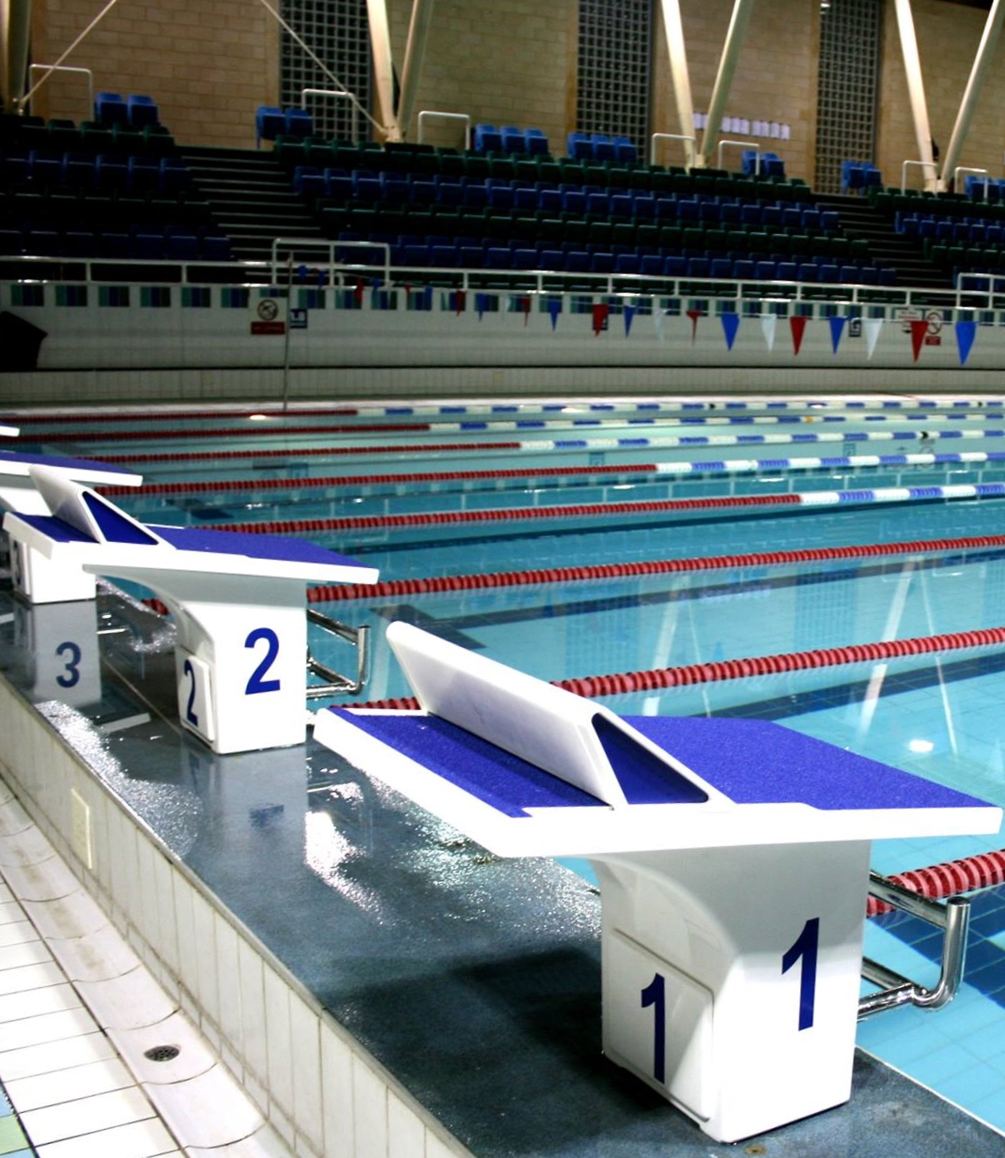
Parkside Swimming Pools, Cambridge.
Cambridge Grand Prix
Level 2 Regional & National
Short Course Qualifier
No. 2ER190459
27th, 28th & 29th September, 2019

City of Cambridge Swimming Club

Cambridge Grand Prix 2019

Cambridge L2 Regional & National Short Course Qualifier (License Number: 2ER190459)

Friday 27th, Saturday 28th and Sunday 29th September, 2019

Affiliated to the Swim England East Region
Under Swim England Regulations and Technical Rules of Racing

Venue: Parkside Swimming Pool, Gonville Place, Cambridge, CB1 1LY

Pool: 8 lane, 25m pool, electronic timing, Olympic-standard blocks, backstroke starting ledges

Age Groups: 10, 11, 12, 13, 14, 15, 16 and over.

Awards: Medals awarded to top three in each age group

Cash prizes: Top Visiting Club – £500
Top male/female 10, 11, 12, 13, 14, 15 and 16+ swimmers – £25 each
Meet record breakers – £25
Spot prizes for randomly selected heats

Events: 50m, 100m and 200m all strokes, 400m freestyle, 200m and 400m IM
Events will run fastest to slowest

Finals: 50m and 100m all strokes

Fees Race Entry Fee: £7.00 per event
Spectator Entry £4.00 per session or £10.00 all day

Entries to City of Cambridge Swimming Club, Parkside Pools, Gonville Place, Cambridge, CB1 1LY

Closing Date: 12.00 Midnight on 14th August, 2019

Enquiries can be e-mailed to meets@cocsc.org.uk

Meet Programme

Session 1 – Friday 27th September
Warm-up 6.15pm – Start 7.15pm
 | Event 101  Event 102 |  |  |  | 200 Freestyle  200 Freestyle |  | Female  Male
 | Session 2 – Saturday 28th September  Warm-up 8am – Start 9am |  |  |  |  | Session 5 – Sunday 29th September  Warm-up 8am – Start 9am
 | Event 201  Event 202 | 400 IM  400 Freestyle |  | Male  Female |  | Event 501  Event 502 |  | 400 IM  400 Freestyle | Female  Male
 | Session 3 – Saturday 28th September  Warm-up tbc – Start tbc |  |  |  |  | Session 6 – Sunday 29th September  Warm-up tbc – Start tbc
 | Event 301  Event 302  Event 303  Event 304  Event 305  Event 306 | 100 Freestyle  200 Backstroke  200 Butterfly  100 Butterfly  50 Backstroke  50 Breaststroke |  | Male  Female  Male  Female  Male  Female |  | Event 601  Event 602  Event 603  Event 604  Event 605  Event 606 |  | 100 Freestyle  200 Backstroke  200 Butterfly  100 Butterfly  50 Backstroke  50 Breaststroke | Female  Male  Female  Male  Female  Male
 | 15 minute break before Finals  Session 3 Finals |  |  |  |  | 15 minute break before Finals  Session 6 Finals
 | Event 307  Event 308  Event 309  Event 310  Event 311  Event 312  Event 313  Event 314 | 100 Freestyle  100 Freestyle  100 Butterfly  100 Butterfly  50 Backstroke  50 Backstroke  50 Breaststroke  50 Breaststroke |  | Male  Male  Female  Female  Male  Male  Female  Female |  | Event 607  Event 608  Event 609  Event 610  Event 611  Event 612  Event 613  Event 614 |  | 100 Freestyle  100 Freestyle  100 Butterfly  100 Butterfly  50 Backstroke  50 Backstroke  50 Breaststroke  50 Breaststroke | Female  Female  Male  Male  Female  Female  Male  Male
 | Session 4 – Saturday 28th September  Warm-up tbc – Start tbc |  |  |  |  | Session 7 – Sunday 29th September  Warm-up tbc – Start tbc
 | Event 401  Event 402  Event 403  Event 404  Event 405  Event 406 | 200 IM  50 Freestyle  50 Butterfly  100 Backstroke  100 Breaststroke  200 Breaststroke | Male  Female  Male  Female  Male  Female |  |  | Event 701  Event 702  Event 703  Event 704  Event 705  Event 706 |  | 200 IM  50 Freestyle  50 Butterfly  100 Backstroke  100 Breaststroke  200 Breaststroke | Female  Male  Female  Male  Female  Male
 | 15 minute break before Finals  Session 4 Finals |  |  |  |  | 15 minute break before Finals  Session 7 Finals
 | Event 407  Event 408  Event 409  Event 410  Event 411  Event 412  Event 413  Event 414 | 50 Freestyle  50 Freestyle  50 Butterfly  50 Butterfly  100 Backstroke  100 Backstroke  100 Breaststroke  100 Breaststroke | Female  Female  Male  Male  Female  Female  Male  Male |  |  | Event 707  Event 708  Event 709  Event 710  Event 711  Event 712  Event 713  Event 714 |  | 50 Freestyle  50 Freestyle  50 Butterfly  50 Butterfly  100 Backstroke  100 Backstroke  100 Breaststroke  100 Breaststroke | Male  Male  Female  Female  Male  Male  Female  Female

Meet Rules and Information

- This Competition is licensed by Swim England and will be held under Swim England Regulations and Technical Rules of Racing, FINA Technical Rules of Swimming and these Meet Rules.
- Entrants must be Swim England registered Category 2, belong to an affiliated club and enter in the name of one club only.
- All entry times must meet the qualifying times and criteria stated on the qualifying times table.
- Swimmers in possession of a Swim England Certificate of Swimming Disability or whose Swim England membership record details a disability sport class are welcome to enter the competition with a time slower than the lower limit standard. An entry time must be provided.
- This is not a first come first served meet. The promoter reserves the right to limit entries. Competitors may be rejected if the meet is oversubscribed in order to meet licence time guidelines. Rejections will be made based on seeded entry time and will be undertaken fairly and equitably across all events, age groups and clubs. The slowest swimmers across each age group would be the first to be rejected..
- All entries of three or more swimmers must be made electronically. Electronic SPORTSYSTEMS Entry Manager files are available on request by e-mail to meets@cocsc.org.uk or from the club website at www.cocsc.org.uk. There will be an administration charge of £20 for group entries not submitted electronically.
- Entry forms and payment must be received by the Promoters before midnight on 14th August 2019 and must be fully and correctly completed, or else they may be rejected.
- The list of accepted and rejected entries will be published/available for download on the club website (www.cocsc.org.uk) approximately two weeks prior to the competition. It is the competing club/swimmer’s responsibility to check this list for accuracy and advise immediately of any mistakes or changes that are required.
- Competitors’ ages shall be as at 31st December 2019.
- 200m and 400m events will be Heats Declared Winners.
- Finals shall be swum for 50m and 100m freestyle, backstroke, breaststroke and butterfly events in the following age groups, 14/Under and 15/Over and will consist of the fastest eight heat swimmers from each of the age groups defined.
- Medals will be awarded to the top three in each age group in each event based on heat performance. Age groups as follows – 10, 11, 12, 13, 14, 15 and 16+.
- Finals will be medalled separately based purely on the finals result for 14/Under and 15/Over.
- Cash prizes of £25 will be awarded to the overall top male/female swimmers in the following age group categories: 10, 11, 12, 13, 14, 15 and 16+. This is based on the highest accumulated number of FINA points scored. Where swimmers achieve points in both a heat and final for an event, the highest score of the two will be counted towards the total.
- Meet record breakers will be awarded a cash prize of £25. Details of current meet record holders will be noted in the programme. For 50m and 100m events the record breakers will be declared after the Finals – only one prize will be given per event.
- Spot prizes will be awarded to randomly selected heat winners. A spot prize heat will be identified prior to the start of the race with a ringing bell. All spot prizes will be awarded at the promoter’s discretion.
- Top point scoring visiting club will receive £500 (calculated on points awarded to the top 8 finishers in each age group).
- Swimmers must withdraw from events that they no longer wish to swim. All swimmers informed of having accepted entries will be deemed as competing unless they have informed the promoter that they do not wish to swim.
- Withdrawals should be made online at https://swim-meet.com/withdrawals (a code for each club will be sent out when the accepted entries list is published) or via e-mail to meets@cocsc.org.uk stating the event number, full name, date of birth, entry time and club. Withdrawals should be made by midnight on Wednesday 25th September.
- Any on the day withdrawals must be made by coaches or the club representative one hour prior to the start of the first event in each session. Withdrawal forms will be included in the coach packs, completed forms should be given to the meet promotor or volunteer co-ordinator via the computer desk.
- Refunds are not available for withdrawals, other than for medical reasons. Any competitor that withdraws on medical grounds will not be able to participate in any events for the remainder of that session.
- The pool length is 25 metres, 8 lanes with anti-wave ropes and electronic timing and the depth of the pool is 1.2m at the shallow end and 1.8m at the deep end.
- Backstroke start devices may be used.
- A secondary strobe light will be available.
- Any swimmer not reporting to the marshalling area in a timely manner, normally one event in advance of their own, may be deemed to have withdrawn from that event.
- All events will be seeded on submitted times. For events with finals the fastest three heats will be cyclically seeded, all other heats and heats declared winners events will be spearheaded.
- Events will run fastest to slowest.
- Coaches/Team Managers will be allowed on poolside if wearing a pre-purchased pass. Coaches and Team Managers must be club trained personnel and clubs are asked to maintain the recommended ratio of helpers to swimmers. Untrained parents without DBS clearance are not allowed poolside.
- Over-the-top starts, and side-by-side starts for backstroke events, may be used at the referees’ discretion.
- The promoters do not accept responsibility for any property.
- For Health and Safety reasons only small rucksack bags will be allowed poolside. Lockers are available (refundable £1 coin required). Pool staff will remove any large obtrusive bags.
- Limited seating poolside will be available for Coaches and swimmers. No additional seating is permitted.
- No person will be allowed on poolside without a pass.
- There will be no glass items allowed on poolside.
- The promoters reserve the right to refuse admission to any competitor, participant, coach or spectator.
- By submitting and accepting entries to the meet, consent is hereby given, as required by the Data Protection Act 2018, to the holding of personal information on computer. Personal data handled such as name, club, recorded and entered times may be made public during or after the meet.
- Charges as follows: Race Entry Fees £7.00 per event, Spectator fees £4.00 per session or £10.00 per day, Programmes £4.00, Coach/Team Manager Passes £12.00 per day (including lunch and a programme), except Friday which is free of charge.
- In accordance with Swim England Child Safety Procedures and Policies all parents or carers of swimmers under the age of 18 who wish to take photographic or video images are requested to focus on their own child as much as reasonably possible and to avoid including other children in those images, particularly if those images are being shared with family and friends through social media platforms. Should you have any concerns about photography or filming at this event then please bring them to the attention of the Meet Promoter, Catherine Pearson.
- Warm up protocol: Strictly no diving during any warm-up sessions, except in the designated sprint lanes, odd lanes will swim clockwise (1, 3, 5, 7) even lanes (2, 4, 6, 8) will swim counter clockwise. All swimmers must leave the water by the side of the pool and not over the timing pads. Coaches must manage the lanes their swimmers are using during the warm up sessions. Guidance will be given by the meet announcer.
- Any matter not covered by these conditions will be determined by the Promoter and Referee, subject to Swim England Regulations and Technical Rules of Racing and FINA Technical Rules of Swimming.

Para Swimming Conditions

The conditions outlined above shall apply to all para swimmers except where varied by any of the following conditions.

- Swimmers with S1- S15 classifications will be accepted.
- All para swimmers must have an internationally authorised classification.
- Competitors must be registered members of Swim England.
- The meet does not have disability consideration times, however the organisers reserve the right to reject swimmers after the closing date if demand exceeds the time available in the galas.
- Personal care attendants will be permitted for swimmers in all disability classes.
- A swimmer may have both a coach and a personal care attendant present.
- The competition format will be based on disability inclusion within the able-bodied programme. Swimmers will be integrated on a time-banded basis in all events.
- Positions will be determined by each swimmer’s times relative to the world record in their own classification.
- Para swimmers will be included but not placed within the results for the appropriate age group in the able-bodied competition unless their entry times meet the qualifying times for the able-bodied competition. They will also be included in the multi-class results and placed within those results according to their equivalent times.
- Winners of all events will be heat declared.
- Competition to be run under IPC Swimming swim rules.
- Medals shall be awarded on a multi-class basis to 1st, 2nd and 3rd place in each event.

Qualifying Times

Qualification times must have been achieved at licensed meets since the 28th September, 2018, converted to 25m pool if necessary. All entry times will automatically be checked against British Rankings for validity. Entries with NT will be rejected.

If the meet is oversubscribed your entry may be rejected even if you are faster than the qualifying times.

MALE
 | 10yrs | 11yrs | 12yrs | 13yrs | 14yrs | 15yrs | 16+ yrs
50m Free | 39.01 | 36.92 | 34.71 | 32.85 | 31.07 | 29.68 | 28.78
100m Free | 1:26.39 | 1:20.60 | 1:15.70 | 1:11.10 | 1:07.30 | 1:04.60 | 1:02.60
200m Free | 3:04.14 | 2:53.05 | 2:43.05 | 2:33.45 | 2:25.13 | 2:19.39 | 2:14.94
400m Free | 6:23.96 | 5:58.68 | 5:39.08 | 5:20.26 | 5:04.19 | 4:51.55 | 4:42.93
50m Breast | 51.30 | 48.00 | 45.10 | 41.90 | 39.60 | 37.70 | 36.40
100m Breast | 1:50.60 | 1:43.40 | 1:36.90 | 1:30.10 | 1:25.10 | 1:21.00 | 1:18.40
200m Breast | 3:56.61 | 3:40.18 | 3:27.11 | 3:13.35 | 3:02.06 | 2:54.04 | 2:48.99
50m Fly | 43.80 | 41.00 | 38.80 | 36.40 | 34.30 | 32.50 | 31.50
100m Fly | 1:46.25 | 1:30.40 | 1:24.60 | 1:19.10 | 1:14.40 | 1:10.70 | 1:08.80
200m Fly | 3:45.99 | 3:26.13 | 3:14.06 | 3:01.69 | 2:51.29 | 2:41.72 | 2:37.77
50m Back | 45.10 | 42.50 | 40.30 | 37.60 | 35.80 | 33.90 | 32.60
100m Back | 1:35.61 | 1:30.05 | 1:24.77 | 1:19.30 | 1:14.63 | 1:11.14 | 1:08.95
200m Back | 3:24.63 | 3:11.37 | 3:00.77 | 2:49.39 | 2:39.79 | 2:32.76 | 2:28.30
200m IM | 3:21.59 | 3:07.72 | 2:57.46 | 2:47.01 | 2:37.03 | 2:30.29 | 2:26.01
400m IM | 7:35.60 | 6:59.70 | 6:34.30 | 6:12.00 | 5:50.30 | 5:34.60 | 5:25.40

FEMALE
 | 10yrs | 11yrs | 12yrs | 13yrs | 14yrs | 15yrs | 16+ yrs
50m Free | 39.60 | 37.02 | 34.73 | 33.49 | 32.52 | 32.26 | 31.76
100m Free | 1:25.93 | 1:21.30 | 1:15.91 | 1:13.39 | 1:10.54 | 1:09.50 | 1:08.70
200m Free | 3:04.93 | 2:53.65 | 2:43.25 | 2:36.42 | 2:31.97 | 2:28.70 | 2:26.52
400m Free | 6:27.79 | 5:57.60 | 5:36.83 | 5:23.20 | 5:14.38 | 5:07.52 | 5:04.00
50m Breast | 51.70 | 48.30 | 45.40 | 43.20 | 41.80 | 40.80 | 40.30
100m Breast | 1:50.70 | 1:43.50 | 1:37.30 | 1:32.30 | 1:28.70 | 1:27.10 | 1:26.20
200m Breast | 3:57.11 | 3:39.88 | 3:26.71 | 3:16.22 | 3:09.59 | 3:06.02 | 3:03.94
50m Fly | 43.90 | 41.30 | 39.10 | 37.30 | 36.10 | 35.20 | 34.70
100m Fly | 1:53.95 | 1:30.90 | 1:24.90 | 1:21.20 | 1:18.30 | 1:16.90 | 1:15.80
200m Fly | 3:48.80 | 3:28.21 | 3:13.86 | 3:04.39 | 2:57.84 | 2:53.58 | 2:51.39
50m Back | 45.30 | 42.70 | 40.50 | 38.47 | 37.26 | 36.74 | 36.01
100m Back | 1:35.77 | 1:29.63 | 1:24.02 | 1:20.18 | 1:17.82 | 1:15.94 | 1:14.96
200m Back | 3:26.61 | 3:10.58 | 2:59.88 | 2:52.56 | 2:47.51 | 2:43.15 | 2:40.78
200m IM | 3:22.06 | 3:08.00 | 2:56.98 | 2:49.86 | 2:44.44 | 2:41.03 | 2:38.84
400m IM | 7:35.30 | 6:57.30 | 6:32.00 | 6:14.40 | 6:03.10 | 5:55.80 | 5:50.50

Individual Entry Form

Please ensure that you eligible to enter a race before completing this form
ENTRY DEADLINE: MIDNIGHT ON 14th August, 2019

First Name |  |  | Surname
Male or Female |  |  | Phone Number
Date of Birth (dd/mm/yy) |  |  | Swim England Reg. No.
Club
Address
E-mail
Disability Exemption Code | S= |  | SB= | SM=
Age as of 31st Dec, 2019 |  | years old
Event |  | Time |  | Fee
50m Freestyle
100m Freestyle
200m Freestyle
400m Freestyle
50m Breaststroke
100m Breaststroke
200m Breaststroke
50m Butterfly
100m Butterfly
200m Butterfly
50m Backstroke
100m Backstroke
200m Backstroke
200m Individual Medley
400m Individual Medley
Total @ £7.00 per event
Payment Method (tick and complete): Cheque (payable to COCSC) BACS Ref: Other:
I hereby declare that the above particulars are correct and that I am an eligible competitor in accordance with the laws
of Swim England and will abide by the conditions laid down by the promoters for this competition.
Signature of Competitor: Date:

Coach/Team Manager Pass Application Form

Club Name:___________________________________________________________________

Closing date 14th August 2019

 | Friday  (£ FOC) | Saturday  (£12 PER PERSON) | Sunday  (£12 PER PERSON)
Full Name:
Position (e.g. Coach):
Telephone No:
Email Address:
DBS Certificate No.:
Full Name:
Position (e.g. Coach):
Telephone No:
Email Address:
DBS Certificate No.:
Full Name:
Position (e.g. Coach):
Telephone No:
Email Address:
DBS Certificate No.:
Full Name:
Position (e.g. Coach):
Telephone No:
Email Address:
DBS Certificate No.:
Number of passes @ £12 per person per day (except Friday). Total: £

The above named person(s) is (are) authorised to hold a pass for this club:

Signed ______________________________________Club Representative

Coach/Team Manager Passes will not be available on the day. There will be no access to poolside without a pass.
Passes include entry to poolside, programme and meal on Saturday and Sunday.
All completed forms to be returned by e-mail to meets@cocsc.org.uk.

Club Summary Entry Form

Please return this completed form by e-mail to meets@cocsc.org.uk.

Closing date 14th August 2019

Club Name:
Contact Name:
Postal Address:
Email Address:
Telephone No:
Entry Details:
 |  |  | No of Entries/ Passes | Cost
Swimmers | @ £7 per event |  |  | £
Coaches Pass | @ £12 per person per day (except Friday) |  |  | £
 |  |  | TOTAL | £

Please make payment by BACS to the following account:

Account Name: City of Cambridge Swimming Club
Account No.: 03013626
Sort code: 20-17-19

Your payment reference should be “CLUB NAME/GP”

Checklist – By the Closing Date of 14th August 2019 please ensure you have e-mailed the following information:

- Club Summary Entry Form (this form)
- Coach/Team Manager Form
- Sportsys Entry File
- Sportsys Meet Entry Report
- BACS transfer details

Officials

CoCSC welcome all officials including trainees.

We have an on-line signing up page, you just need your Swim England number:

https://swim-meet.com/OfficialsSignUp/CambridgeGrandPrix2019/

Please click on the link above to select the sessions that you can help with.
Add any mentoring requests and we will do our best to accommodate.

We provide lunch and refreshments for those doing more than one session and payment for expenses incurred in travel.

Car parking can be a problem around the pool, but we may have parking spaces allocated locally for officials - this will be advised nearer the time.

Any additional questions please email officials@cocsc.org.uk

