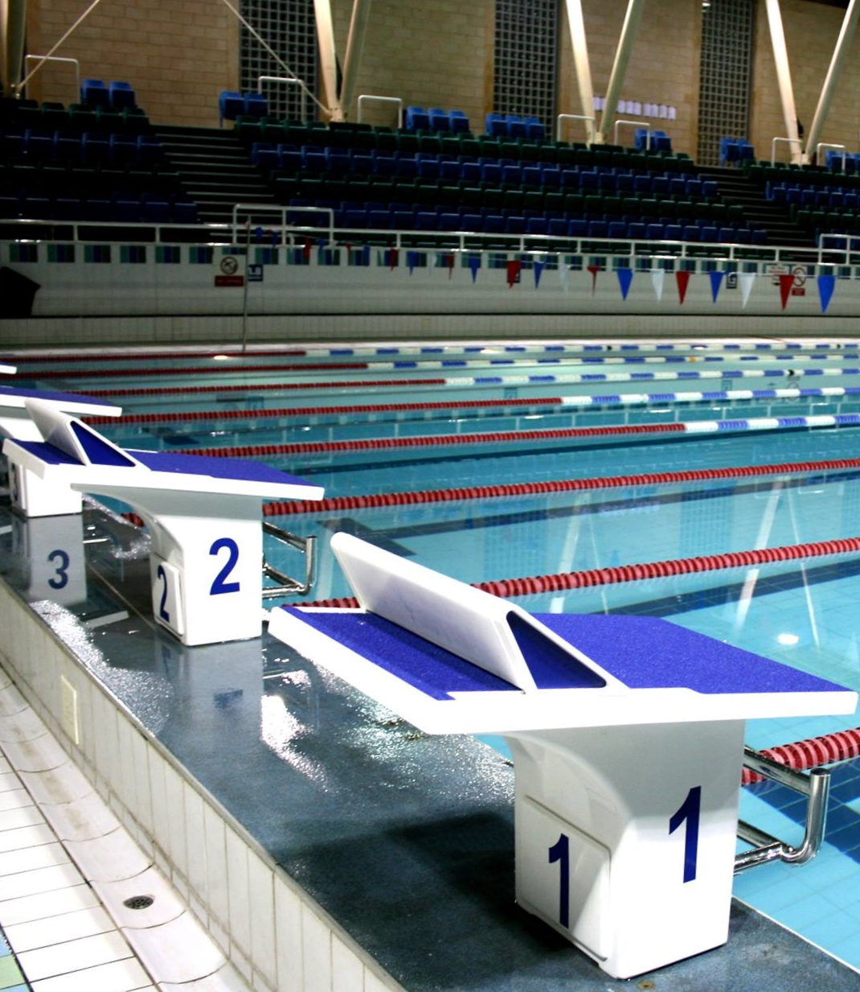

City of Cambridge Swimming Club
Parkside Swimming Pools, Cambridge.
Cambridge Spring
Open 2018
Level 3 No. 3ER180509
23th, 24th & 25th March, 2018

City of Cambridge Swimming Club

Cambridge Spring Open 2017

(License Number: 3ER180509)

Friday 23th, Saturday 24th and Sunday 25th March 2018
Under ASA Laws & Technical Rules: Affiliated to the East Region ASA

Venue: Parkside Swimming Pool, Gonville Place, Cambridge, CB1 1LY
Queen Anne Car Park is adjacent to the pool.

Pool: 8 Lane, 25m Pool, Electronic Timing, Olympic standard blocks.

Age Groups: 9, 10, 11, 12, 13, 14, 15, 16 and over. For event restrictions see qualifying times table.

Awards: Heat Declared Winners with awards to top three in each age group.

Events: 50m, 100m and 200m all strokes, 400m Freestyle and 200m and 400m IM.

Fees Race Entry Fee: £6.00 per event
Spectator Entry £3.00 per session or £5.00 all day.

Entries to Meets Secretary,
City of Cambridge Swimming Club, Parkside Pools, Gonville Place, Cambridge, CB1 1LY

Enquiries can be e-mailed to meets@cocsc.org.uk

Closing Date for Entries: 12.00 Midnight on 23nd February, 2018.

Meet Programme

Session 1
Friday 23th March
Warm-up 6.15pm
Start 7.15pm
101  102  103  104  105  106 |  | 50m Butterfly  50m Butterfly  50m Backstroke  50m Backstroke  50m Breaststroke  50m Breaststroke |  |  | Female  Male  Female  Male  Female  Male
Session 2  Saturday 24th March  Warm-up 12pm  Start 1pm |  |  | Session 4  Sunday 25th March  Warm-up 11am  Start 12pm
201  202  203  204  205  206 | 100m Freestyle  100m Freestyle  200m IM  200m Butterfly  200m Butterfly  50m Freestyle | Male  Female  Male  Female  Male  Female | 401  402  403  404  405  406 | 400m Freestyle  100m Butterfly  100m Butterfly  200m Freestyle  200m Freestyle  50m Freestyle |  | Female  Male  Female  Male  Female  Male
Session 3  Saturday 24th March  Warm-up tbc  Start tbc |  |  | Session 5  Sunday 25th March  Warm-up tbc  Start tbc
301  302  303  304  305  306 | 400m IM  400m Freestyle  100m Breaststroke  100m Breaststroke  200m Backstroke  200m Backstroke | Female  Male  Female  Male  Female  Male | 501  502  503  504  505  506 | 400m IM  200m IM  100m Backstroke  100m Backstroke  200m Breaststroke  200m Breaststroke |  | Male  Female  Male  Female  Male  Female
Timings noted above are indicative, and may alter slightly.
Final timings will be confirmed shortly before the meet.

Meet Rules and Information

- This Competition is licensed by the ASA and will be held under ASA Laws and ASA Technical Rules.
- Entrants must be ASA Registered CAT 2, belong to an affiliated club and enter in the name of one club only.
- This is a first come first served meet. The promoter reserves the right to limit entries. Competitors may be rejected if the meet is oversubscribed in order to meet license time guidelines.
- All entries of 3 or more swimmers must be made electronically. Electronic Sportsys entry files are available on request by email meets@cocsc.org.uk or from the club website at www.cocsc.org.uk. There will be an administration charge of £20 for group entries not submitted electronically.
- Entry forms and payment must be received by the Promoters before midnight on 23nd February 2018 and must be fully and correctly completed, or else they may be rejected.
- Swimmers in possession of an ASA Certificate of Swimming Disability or whose ASA membership record details a disability sport class and compete within the ASA are welcome to enter the competition with a time slower than the lower limit standard. An entry time must be provided.
- The list of accepted and rejected entries will be published/available for download on the club website (www.cocsc.org.uk) approximately two weeks prior to the competition. It is the competing club/swimmer’s responsibility to check this list for accuracy and advise immediately of any mistakes or changes that are required.
- Competitors’ ages shall be as at 25th March 2018.
- 9 year old swimmers are not eligible to enter 100m events.
- All events will run as Timed Finals. Awards will be made for the top three in each age group in each event.
- Swimmers must withdraw from events that they no longer wish to swim. All swimmers informed of having accepted entries will be deemed as competing unless they have informed the promoter that they do not wish to swim.
- Withdrawals should be made via email to meets@cocsc.org.uk by midnight on Wednesday 21st March, 2018 stating the event number, full name, date of birth, entry time and club.
- Any on the day withdrawals must be made by coaches or the club representative 1 hour prior to the start of the first event in each session. Withdrawal forms will be included in the coach packs, completed forms should be given to the meet promotor or volunteer co-ordinator via the computer desk.
- Swimmers failing to attend the start of a heat without withdrawing will incur a £10 penalty, which must be paid by the swimmer or the club before the swimmer is allowed to participate further in the meet.
- Refunds are not available for withdrawals, other than for medical reasons.
- Any competitor that withdraws on medical grounds will not be able to participate in any events for the remainder of that session.
- The pool length is 25 metres, 8 lanes with anti-wave ropes and electronic timing and the depth of the pool is 1.2m at the shallow end and 1.8m at the deep end.
- Backstroke start devices may be used.
- Competitors must report to the marshalling area in a timely manner, normally 1 event in advance of their own, where they will be given their start order. Any swimmer not reporting may be deemed to have withdrawn from that event.
- All events will be seeded on submitted times and the fastest heat will be spearheaded. The first three swimmers in each event in each age group will receive awards.
- Coaches/Team Managers will be allowed on poolside if wearing a pass.
- Coach Passes are available free of charge for the Friday evening session, or at £12 per day for Saturday or Sunday which includes a meal at lunchtime, a programme and a full set of results.
- Coaches and Team Managers must be club trained personnel and clubs are asked to maintain the recommended ratio of 1:20 helpers/swimmers. Untrained parents without CRB are not allowed poolside.
- Over the top starts may be used at the referees’ discretion.
- The promoters do not accept responsibility for any property.
- For Health and Safety reasons only small rucksack bags will be allowed poolside. Lockers are available with a £1 token purchased from reception (non-refundable) Pool staff will remove any large obtrusive bags.
- Limited seating poolside will be available for Coaches and swimmers. No additional seating is permitted.
- No person will be allowed on poolside without a pass.
- There will be no glass items allowed on poolside.
- The promoters reserve the right to refuse admission to any competitor, participant, coach or spectator.
- City of Cambridge Swimming Club uses a computer to manage entries and results. By submitting and accepting entries to the meet consent is hereby given, as required by the Data Protection Act 1998, to the holding of personal information on computer. Personal data handled such as name, club, recorded and entered times may be made public during or after the meet.
- Charges as follows: Race Entry Fees £6.00 per event, Coaches Passes £12.00 per day (except Friday), Spectator fees £3.00 per session or £5.00 per day, Programmes £3.00.
- In accordance with the ASA Child Safety Procedures and Policies all parents or carers of swimmers under the age of 18 who wish to take photographic or video images are requested to focus on their own child as much as reasonably possible and to avoid including other children in those images, particularly if those images are being shared with family and friends through social media platforms. Should you have any concerns about photography or filming at this event then please bring them to the attention of the Meet Promoter, Catherine Pearson.
- Warm up protocol: Strictly no diving during any warm-up sessions, except in the designated sprint lanes, odd lanes will swim clockwise (1, 3, 5, 7) even lanes (2, 4, 6, 8) will swim counter clockwise. All swimmers must leave the water by the side of the pool and not over the timing pads. Coaches should manage the lanes their swimmers are using during the warm up sessions. Guidance will be given by the meet announcer and Warm Up Marshalls. Warm up schedule will be issued to Coaches on arrival.
- Any matter not covered by these conditions will be determined by the Promoter and Referee, subject to ASA Laws, Regulations and the ASA Technical Rules of Racing.

Disability Swimming Conditions

The conditions outlined above shall apply to the Disability Swimming events except where varied by any of the following conditions.

Eligibility
- Swimmers with S1- S15 classifications will be accepted.
- All swimmers must have an internationally authorised classification.
- Competitors must be registered members of the ASA.
- The meet does not have disability consideration times, however the organisers reserve the right to reject swimmers after the closing date if demand exceeds the time available in the galas.

Personal Care Attendants
- Personal care attendants will be permitted for swimmers in all disability classes.
- A swimmer may have both a coach and a personal care attendant present.

Competition Format
- The competition format will be based on disability inclusion within the able-bodied programme. Swimmers will be integrated on a time-banded basis in all events.
- Positions will be determined by each swimmer’s times relative to the world record in their own classification.
- Disability swimmers will be included but not placed within the results for the appropriate age group in the able-bodied competition unless their entry times meet the qualifying times for the able-bodied competition. They will also be included in the Multi Disability results and placed within those results according to their equivalent times.
- Winners of all events will be heat declared.
- Competition to be run under IPC Swimming swim rules.
- An official who holds the qualification of ASA Disability Official will act as a technical advisor in each of the sessions where disability athletes are entered, if available.

Medals
- Medals shall be awarded on a multi-disability basis to 1st, 2nd and 3rd place in each event. Medals shall be awarded following the posting of the results after the relevant event has taken place.
- Placing shall be determined by achieving a time better than or closest to, the equivalent World record relevant to their own classification.

Qualifying Times

Qualification times must have been achieved at licensed meets since the 24th March 2017, converted to 25m pool if necessary.
All entry times will automatically be checked against British Rankings for validity.
If the meet is oversubscribed your entry may be rejected even if meet the qualifying times.
Entries with “No Time” will automatically be rejected.
 | FEMALE QUALIFYING TIMES
 | Entry Times to be faster than or equal to |  |  |  |  |  |  |  | Entry times to be slower than
Event | 9yrs | 10yrs | 11yrs | 12yrs | 13yrs | 14yrs | 15yrs | 16+ yrs. | All Age Groups
50fr | 54.99 | 51.80 | 49.21 | 46.85 | 45.19 | 44.01 | 43.07 | 42.48 | 27.78
100fr |  | 1.35.96 | 1.35.96 | 1.30.68 | 1.27.19 | 1.24.71 | 1.23.13 | 1.21.78 | 59.66
200fr | 3.49.35 | 3.29.88 | 3.17.34 | 3.05.79 | 2.58.20 | 2.53.25 | 2.50.72 | 2.47.20 | 2.07.43
400fr | 8.14.34 | 7.19.67 | 6.45.79 | 6.22.47 | 6.07.18 | 5.57.28 | 5.49.58 | 5.45.62 | 4.32.17
50br | 1.10.68 | 1.05.72 | 1.01.71 | 58.29 | 55.70 | 54.04 | 53.45 | 52.27 | 35.91
100br |  | 2.00.94 | 2.00.94 | 1.53.96 | 1.48.34 | 1.44.29 | 1.42.49 | 1.41.48 | 1.16.33
200br | 4.50.40 | 4.27.85 | 4.08.71 | 3.54.08 | 3.42.42 | 3.35.05 | 3.31.09 | 3.28.78 | 2.44.80
50fly | 1.01.24 | 56.52 | 53.45 | 50.86 | 48.73 | 47.32 | 46.26 | 45.67 | 29.58
100fly |  | 1.46.76 | 1.46.76 | 1.40.01 | 1.35.85 | 1.32.59 | 1.31.01 | 1.29.78 | 1.05.32
200fly | 4.40.50 | 4.06.40 | 3.44.62 | 3.29.44 | 3.19.43 | 3.12.50 | 3.07.99 | 3.05.68 | 2.24.23
50bk | 1.02.42 | 58.17 | 55.11 | 52.51 | 50.39 | 48.97 | 48.14 | 47.32 | 31.96
100bk |  | 1.46.88 | 1.46.88 | 1.40.46 | 1.36.08 | 1.33.37 | 1.31.23 | 1.30.11 | 1.06.23
200bk | 4.13.22 | 3.53.97 | 3.36.15 | 3.24.27 | 3.16.13 | 3.10.52 | 3.05.68 | 3.03.04 | 2.21.88
200IM | 4.21.36 | 3.58.37 | 3.42.09 | 3.30.43 | 3.21.08 | 3.14.81 | 3.10.85 | 3.08.32 | 2.26.02
400IM | 9.04.83 | 8.26.33 | 7.36.83 | 7.16.70 | 6.57.34 | 6.44.91 | 6.36.88 | 6.31.05 | 5.11.52

 | MALE QUALIFYING TIMES
 | Entry Times to be faster than or equal to |  |  |  |  |  |  |  | Entry times to be slower than
Event | 9yrs | 10yrs | 11yrs | 12yrs | 13yrs | 14yrs | 15yrs | 16+ yrs. | All Age Groups
50fr | 54.4 | 51.09 | 48.62 | 46.14 | 43.78 | 41.65 | 40 | 38.94 | 24.73
100fr |  | 1.36.18 | 1.36.18 | 1.29.66 | 1.24.48 | 1.20.21 | 1.17.17 | 1.14.92 | 54.31
200fr | 3.47.48 | 3.29.09 | 3.16.68 | 3.05.57 | 2.54.9 | 2.45.66 | 2.39.28 | 2.34.33 | 1.57.17
400fr | 8.31.06 | 7.15.38 | 6.47.00 | 6.25.00 | 6.03.88 | 5.45.84 | 5.31.65 | 5.21.97 | 4.09.87
50br | 1.09.74 | 1.05.25 | 1.01.36 | 57.94 | 54.16 | 51.45 | 49.21 | 47.67 | 30.72
100br |  | 2.00.6 | 2.00.6 | 1.53.51 | 1.45.86 | 1.40.23 | 1.35.62 | 1.28.2 | 1.09.5
200br | 4.47.98 | 4.27.3 | 4.09.04 | 3.54.52 | 3.39.23 | 3.26.69 | 3.17.78 | 3.07.67 | 2.30.63
50fly | 1.00.52 | 56.4 | 53.1 | 50.5 | 47.67 | 45.19 | 43.07 | 41.89 | 25.93
100fly |  | 1.46.20 | 1.46.20 | 1.39.67 | 1.33.49 | 1.28.20 | 1.24.03 | 1.21.9 | 59.04
200fly | 4.37.53 | 4.03.43 | 3.42.42 | 3.29.66 | 3.16.57 | 3.05.57 | 2.55.45 | 2.51.27 | 2.12.26
50bk | 1.02.06 | 57.94 | 54.87 | 52.27 | 49.09 | 46.96 | 44.72 | 40.83 | 28.78
100bk |  | 1.46.76 | 1.46.76 | 1.40.35 | 1.34.16 | 1.28.87 | 1.24.93 | 1.21.34 | 1.00.35
200bk | 3.47.80 | 3.30.70 | 3.17.30 | 3.06.60 | 2.55.10 | 2.45.40 | 2.38.30 | 2.32.80 | 2.10.37
200IM | 4.17.07 | 3.53.42 | 3.41.76 | 3.29.88 | 3.17.78 | 3.06.23 | 2.58.42 | 2.53.47 | 2.12.75
400IM | 9.10.66 | 8.26.66 | 7.48.27 | 7.20.25 | 6.58.00 | 6.30.83 | 6.14.66 | 6.00.47 | 4.45.25

Swimmer Entry Form

Please ensure that you eligible to enter a race before completing this form.

ENTRY DEADLINE: MIDNIGHT ON 23nd FEBRUARY 2018
First Name: |  |  | Surname:
Male or Female |  |  | Phone Number
DOB (dd/mm/yy) |  |  | ASA Reg. No
Club
Address
Email
Disability Exemption Code | S= |  | SB= | SM=
Age as of 25th March 2018 |  | Yrs. old
Event |  | Time |  | Fee
50m Freestyle
100m Freestyle
200m Freestyle
400m Freestyle
50m Breaststroke
100m Breaststroke
200m Breaststroke
50m Butterfly
100m Butterfly
200m Butterfly
50m Backstroke
100m Backstroke
200m Backstroke
200m Individual Medley
400m Individual Medley
Total @ £6.00 per event
Payment Method (tick and complete): Cheque (payable to CoCSC) ◻ BACS ◻ Ref: Other: ◻
I hereby declare that the above particulars are correct and that I am an eligible competitor in accordance with the laws
of the ASA and will abide by the conditions laid down by the promoters for this competition.
Signature of Competitor: Date:

Coach/Helper Pass Application Form

Club Name:___________________________________________________________________

Closing date 23rd February 2018

 | Friday Coach/Helpers (£ FOC) | Saturday Coach/Helpers  (£12 PER PERSON) | Sunday Coach/Helpers  (£12 PER PERSON)
Full Name:
Full Name:

Position:
Position:
(e.g. Coach)
Address:

Address:

Telephone No:
Telephone No:
Email Address:
Email Address:
ASA Affiliation Number:
ASA Affiliation Number:
Number of passes @ £12 Total enclosed: £

The above named person(s) is (are) authorised to hold a pass for this club:

Signed ______________________________________Club Secretary

Coach Passes will not be available on the day. There will be no access to poolside without a pass.

Coach Passes are free of charge for Friday evening, or £12 per day for Saturday or Sunday.

Passes include entry to poolside, programme and results service.

All completed forms to be returned to:
City of Cambridge Swimming Club Parkside Pools,
Gonville Place,
Cambridge
CB1 1LY

Please address any questions to meets@cocsc.org.uk.

Officials Request Form
We will provide lunch and refreshments for those doing more than one session and payment for expenses incurred in travel and parking will be offered.

Full Name:

Qualification  (tick box applicable): | JL1 | JL2 | JL2S | Referee
Date License Valid To: |  |  | License number:
Sessions  Available: | S1
Sessions  Available: | S2
Sessions  Available: | S3
Sessions  Available: | S4
Sessions  Available: | S5
Mobile No:

Email Address:

Club:

Swimmer’s Name

Mentor Request | If you are in the middle of training to become an official and require mentoring, please indicate the sessions you are available and use this box to detail the tasks you require mentoring for.

Please complete one form per official and submit with your Club Summary Entry form or email to meets@cocsc.org.uk .

Club Summary Entry Form

Please return this completed form with your entries and a SINGLE Cheque* payable to City of Cambridge Swimming Club, and send to
Open Meets Secretary, City of Cambridge Swimming Club, Parkside Swimming Pools, Gonville Place, Cambridge, CB1 1LY

Closing date 23rd February 2018

Club Name:
Contact Name:
Postal Address:
Email Address:
Telephone No:
Entry Details:
 |  |  | No of Entries/ Passes | Cost
Swimmers | @ £6.00 per event |  |  | £
Coaches Pass | @ £12 per person per day |  |  | £
 |  |  |  | £
 |  |  | TOTAL | £
Payment Method (tick and complete): Cheque ◻ BACS* ◻ Ref: Other: ◻

* If you wish to pay by BACS please email meets@cocsc.org.uk for details.

Checklist – By the Closing Date of 23rd February please ensure you have:

Emailed:
Club Summary Entry Form (this form)
Sportsys Meet Entry File
Sportsys Meet Entry Report
Coach/Helper Forms
Officials Forms
(BACS transfer)

Posted:
Club Summary Entry Form (this form)
Sportsys Meet Entry Report
Coach/Helper Forms
Officials Forms
Cheque (payable to CoCSC)

