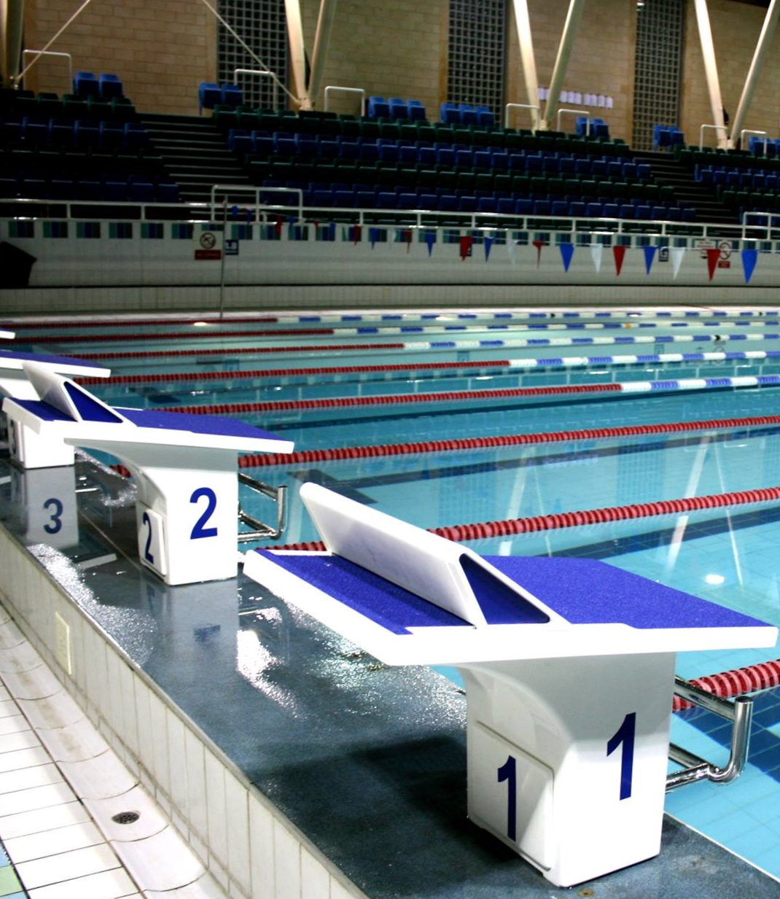

City of Cambridge Swimming Club

Parkside Swimming Pools, Cambridge.
Jeanne Barker
July Open
Level 3 No. 3ER180506
14th & 15th July, 2018

City of Cambridge Swimming Club

Jeanne Barker July Open Level 3 Short Course Meet 2018

(License Number: 3ER180506)

14th and 15th July, 2018

Under ASA Laws & Technical Rules: Affiliated to the East Region ASA

Venue: Parkside Swimming Pool, Gonville Place, Cambridge, CB1 1LY

Pool: 8 Lane, 25m Pool, Electronic Timing, Olympic standard blocks

Age Groups: 9, 10, 11, 12, 13, 14, 15 and over

Awards: Heat Declared Winners with awards to top three in each age group

Events: 50m, 100m and 200m all strokes, 100m and 200m IM

Fees: Race Entry Fee: £6.00 per event
Spectator Entry: £3.00 per session or £5.00 all day

Entries to: City of Cambridge Swimming Club, Parkside Pools, Gonville Place, Cambridge, CB1 1LY

Closing Date for Entries: 12.00 Midnight on 13th June, 2018

Meet Programme

Session 1  Saturday 14th July  Warm-up 12pm  Start 1pm |  |  | Session 3  Sunday 15th July  Warm-up 11am  Start 12pm
1  2  3  4  5  6  7 | 200m IM  50m Breaststroke  50m Butterfly  200m Backstroke  200m Breaststroke  100m Butterfly  100m Freestyle | Female  Male  Female  Male  Female  Male  Female | 15  16  17  18  19  20  21 | 200m IM  50m Breaststroke  50m Butterfly  200m Backstroke  200m Breaststroke  100m Butterfly  100m Freestyle | Male  Female  Male  Female  Male  Female  Male
Session 2  Saturday 14th July  Warm-up tbc  Start tbc |  |  | Session 4  Sunday 15th July  Warm-up tbc  Start tbc
8  9  10  11  12  13  14 | 50m Freestyle  50m Backstroke  100m IM  200m Freestyle  200m Butterfly  100m Backstroke  100m Breaststroke | Male  Female  Male  Female  Male  Female  Male | 22  23  24  25  26  27  28 | 50m Freestyle  50m Backstroke  100m IM  200m Freestyle  200m Butterfly  100m Backstroke  100m Breaststroke | Female  Male  Female  Male  Female  Male  Female

Timings noted above are indicative, and may alter slightly.
Final timings will be confirmed shortly before the meet.

Meet Rules and Information

- This Competition is licensed by the ASA and will be held under ASA Laws and ASA Technical Rules.
- Entrants must be ASA Registered Category 2, belong to an affiliated club and enter in the name of one club only.
- This is not a first come first served meet. The promoter reserves the right to limit entries. Competitors may be rejected if the meet is oversubscribed in order to meet licence time guidelines. As the meet has only upper cut off times, the fastest swimmers across each age group would be the first to be rejected.
- Club entries for more than 3 swimmers must be submitted electronically. Sportsys entry files will be available on the club website at www.cocsc.org.uk or by email from meets@cocsc.org.uk.
- Entry forms and payment must be received by the Promoters before midnight on the 13th June 2018 and be fully and correctly completed, or else they may be rejected.
- The list of accepted and rejected entries will be published/available for download on the club website (www.cocsc.org.uk) approximately two weeks prior to the competition. It is the competing club/swimmer’s responsibility to check this list for accuracy and advise immediately of any mistakes or changes that are required.
- Competitors’ ages shall be as at 15th July 2018.
- The meet promoter will check entries against the British Rankings where it is felt that a swimmer may be submitting a slower time in order to gain entry to this meet. Falsely entered times will be rejected without a refund.
- Swimmers must withdraw from events that they no longer wish to swim. All swimmers informed of having accepted entries will be deemed as competing unless they have informed the promoter that they do not wish to swim.
- Withdrawals should be made via email to meets@cocsc.org.uk by midnight on Thursday 12th July, 2018 stating the event number, full name, date of birth, entry time and club.
- Any on the day withdrawals must be made by coaches or the club representative one hour prior to the start of the first event in each session. Withdrawal forms will be included in the coach packs, completed forms should be given to the meet promotor or volunteer co-ordinator via the computer desk.
- Swimmers failing to attend the start of a heat without withdrawing will incur a £10 penalty, which must be paid by the swimmer or the club before the swimmer is allowed to participate further in the meet.
- Refunds are not available for withdrawals, other than for medical reasons.
- Backstroke start devices may be used.
- The pool length is 25 metres, 8 lanes with anti-wave ropes and electronic timing and the depth of the pool is 1.2m at the shallow end and 1.8m at the deep end.
- Competitors must report to the marshalling area in a timely manner, normally one event in advance of their own, where they will be given their start order. Any swimmer not reporting may be deemed to have withdrawn from that event.
- All events will be seeded on submitted times and all heats will be spearheaded. The first three swimmers in each event in each age group will receive awards.
- Team Managers/Coaches will be allowed on poolside if wearing a pre-purchased pass. Passes can be requested with the entry forms and will be £12.00 per person and include lunch and a programme. Coaches and Team Managers must be qualified personnel and clubs are asked to maintain the recommended ratio of 1:10 helpers/swimmers. Untrained parents without DBS clearance are not allowed poolside.
- Over the top starts may be used at the referees’ discretion.
- The promoters do not accept responsibility for any property.
- For Health and Safety reasons only small rucksack bags will be allowed poolside. Lockers are available with a £1 coin (refundable) Pool staff will remove any large obtrusive bags.
- Limited seating poolside will be available for Coaches and swimmers. No additional seating is permitted.
- No person will be allowed on poolside without a pass.
- There will be no glass items allowed on poolside.
- The promoters reserve the right to refuse admission to any competitor, participant, coach or spectator.
- City of Cambridge Swimming Club uses a computer to manage entries and results. By submitting and accepting entries to the meet consent is hereby given, as required by the Data Protection Act 1998, to the holding of personal information on computer. Personal data handled such as name, club, recorded and entered times may be made public during or after the meet.
- Charges as follows: Race Entry Fees £6.00 per event, Coaches Passes £12.00, Spectator fees £3.00 per session or £5.00 per day, Programmes £3.00.
- In accordance with the ASA Child Safety Procedures and Policies all parents or carers of swimmers under the age of 18 who wish to take photographic or video images are requested to focus on their own child as much as reasonably possible and to avoid including other children in those images., particularly if those images are being shared with family and friends through social media platforms. Should you have any concerns about photography or filming at this event then please bring them to the attention of the Meet Promoter, Catherine Pearson.
- Warm up protocol: Strictly no diving during any warm-up sessions, except in the designated sprint lanes, odd lanes will swim clockwise (1, 3, 5, 7) even lanes (2, 4, 6, 8) will swim counter clockwise. All swimmers must leave the water by the side of the pool and not over the timing pads. Coaches should manage the lanes their swimmers are using during the warm up sessions. Guidance will be given by the meet announcer and Warm Up Marshalls.
- Any matter not covered by these conditions will be determined by the Promoter and Referee, subject to ASA Laws, Regulations and the ASA Technical Rules of Racing.

Disability Swimming Conditions
The conditions outlined above shall apply to the Disability Swimming events except where varied by any of the following conditions.

- Swimmers with S1- S15 classifications will be accepted.
- All swimmers must have an internationally authorised classification.
- Competitors must be registered members of the ASA.
- The meet does not have disability consideration times, however the organisers reserve the right to reject swimmers after the closing date if demand exceeds the time available in the galas.
- Personal care attendants will be permitted for swimmers in all disability classes.
- A swimmer may have both a coach and a personal care attendant present.
- The competition format will be based on disability inclusion within the able-bodied programme. Swimmers will be integrated on a time-banded basis in all events.
- Positions will be determined by each swimmer’s times relative to the world record in their own classification.
- Disability swimmers will be included but not placed within the results for the appropriate age group in the able-bodied competition unless their entry times meet the qualifying times for the able-bodied competition. They will also be included in the Multi Disability results and placed within those results according to their equivalent times.
- Winners of all events will be heat declared.
- Competition to be run under IPC Swimming swim rules.
- An official who holds the qualification of ASA Disability Official will act as a technical advisor in each of the sessions where disability athletes are entered, if available.
- Medals shall be awarded on a multi-disability basis to 1st, 2nd and 3rd place in each event. Medals shall be awarded following the posting of the results after the relevant event has taken place.
- Placing shall be determined by achieving a time better than or closest to, the equivalent World record relevant to their own classification.

Qualifying Cut off Times

Entries with “No Time” will automatically be rejected.
Entries faster than the times shown below will be rejected.
If the meet is oversubscribed your entry may be rejected even if it meets the qualifying times.

Upper Cut Off Times

MALE
 | 9yrs | 10yrs | 11yrs | 12yrs | 13yrs | 14yrs | 15yrs +
50m Free | 37.90 | 34.23 | 31.86 | 30.02 | 28.40 | 26.66 | 25.85
100m Free | 1.25.77 | 1.17.53 | 1.10.79 | 1.06.41 | 1.02.38 | 58.63 | 56.41
200m Free | 2.55.29 | 2.42.10 | 2.29.95 | 2.23.71 | 2.14.51 | 2.07.65 | 2.03.78
50m Breast | 51.15 | 46.73 | 42.62 | 39.05 | 36.52 | 33.82 | 33.06
100m Breast | 1.46.59 | 1.38.14 | 1.33.15 | 1.25.96 | 1.19.59 | 1.13.01 | 1.11.25
200m Breast | 3.51.35 | 3.33.83 | 3.17.99 | 3.06.67 | 2.53.43 | 2.39.71 | 2.34.45
50m Fly | 44.92 | 38.88 | 36.30 | 33.64 | 31.07 | 29.36 | 28.42
100m Fly | 1.48.65 | 1.30.23 | 1.21.60 | 1.15.62 | 1.10.44 | 1.05.20 | 1.01.37
200m Fly | 3.16.75 | 3.18.94 | 2.57.27 | 2.45.56 | 2.33.34 | 2.20.86 | 2.16.01
50m Back | 44.08 | 39.76 | 36.57 | 34.84 | 32.48 | 30.39 | 29.82
100m Back | 1.32.69 | 1.25.21 | 1.18.37 | 1.14.86 | 1.09.52 | 1.05.44 | 1.03.70
200m Back | 3.29.32 | 3.01.64 | 2.49.88 | 2.41.12 | 2.30.50 | 2.23.61 | 2.18.33
100m IM | 1.41.61 | 1.30.10 | 1.21.96 | 1.17.45 | 1.12.25 | 1.07.59 | 1.05.41
200m IM | 3.28.38 | 3.01.40 | 2.53.35 | 2.43.10 | 2.31.19 | 2.22.91 | 2.19.26

FEMALE
 | 9yrs | 10yrs | 11yrs | 12yrs | 13yrs | 14yrs | 15yrs +
50m Free | 38.69 | 34.67 | 31.90 | 30.18 | 29.23 | 28.46 | 28.08
100m Free | 1.28.25 | 1.16.52 | 1.10.54 | 1.04.98 | 1.03.73 | 1.01.64 | 1.00.57
200m Free | 2.56.91 | 2.39.49 | 2.31.85 | 2.21.99 | 2.18.42 | 2.14.05 | 2.09.73
50m Breast | 51.76 | 46.46 | 41.76 | 38.49 | 37.60 | 36.33 | 36.03
100m Breast | 1.48.18 | 1.38.74 | 1.31.49 | 1.23.75 | 1.21.11 | 1.17.71 | 1.17.74
200m Breast | 3.51.56 | 3.30.98 | 3.18.00 | 3.02.65 | 2.56.88 | 2.50.95 | 2.49.27
50m Fly | 48.53 | 38.87 | 35.51 | 32.82 | 31.81 | 30.91 | 30.58
100m Fly | 2.01.54 | 1.25.90 | 1.24.16 | 1.13.91 | 1.11.38 | 1.08.81 | 1.07.18
200m Fly | 3.49.04 | 3.03.50 | 3.03.55 | 2.39.40 | 2.34.33 | 2.29.19 | 2.23.61
50m Back | 44.84 | 39.79 | 36.99 | 34.06 | 33.85 | 32.00 | 31.60
100m Back | 1.34.52 | 1.24.26 | 1.20.51 | 1.12.57 | 1.11.38 | 1.07.71 | 1.07.12
200m Back | 3.23.24 | 3.02.28 | 2.49.45 | 2.37.61 | 2.32.93 | 2.27.62 | 2.25.73
100m IM | 1.41.52 | 1.28.61 | 1.23.87 | 1.15.52 | 1.13.20 | 1.11.24 | 1.10.14
200m IM | 3.33.32 | 3.02.53 | 2.55.32 | 2.41.35 | 2.34.95 | 2.30.58 | 2.27.08

Club Summary Entry Form

Please return this completed form with your entries and a SINGLE cheque* payable to City of Cambridge Swimming Club, to: City of Cambridge Swimming Club, Parkside Pools, Gonville Place, Cambridge CB1 1LY

Closing date 12.00 Midnight on 13th June 2018

Club Name:
Contact Name:
Postal Address:
Email Address:
Telephone No:
Entry Details:
 |  |  | No of Entries/ Passes | Cost
Swimmers | @ £6 per event |  |  | £
Coaches Pass | @ £12 |  |  | £
 |  |  |  | £
 |  |  | TOTAL | £
* If you wish to pay by BACS please e-mail meets@cocsc.org.uk for details.

Checklist – By the Closing Date of 13th June 2018 please ensure you have:

E-mailed:
Club Summary Entry Form (this form)
Sportsys Entry File
Sportsys Meet Entry Report
Coach/Helper Forms
Officials Forms
(BACS Transfer)

Posted:
Club Summary Entry Form (this form)
Sportsys Meet Entry Report
Coach/Helper Forms
Officials Forms
Cheque (payable to CoCSC)

Individual Entry Form
PLEASE NOTE: Entries for more than three swimmers should be made electronically.

First Name: |  |  | Surname:
Male or Female |  |  | Phone Number
DOB (dd/mm/yy) |  |  | ASA Reg. No
Club
Address
Email
Disability Exemption Code | S = |  | SB = |  |  | SM =
Age as of 15th July 2018 |  | ______ Yrs old
Event |  | Submitted Time* |  | Fee
50m Freestyle |  |  |  |  | Individual entries  For individual entries direct to the City of Cambridge Swimming Club, please print your name clearly on the reverse side of your cheque. If your Club is making a group entry, check with your club how payment and application should be made. If you wish to pay by BACS please e-mail meets@cocsc.org.uk for details.
100m Freestyle
200m Freestyle
50m Backstroke
100m Backstroke
200m Backstroke
50m Breaststroke
100m Breaststroke
200m Breaststroke
50m Butterfly
100m Butterfly |  |  |  |  | Club entries  Clubs please complete a Club Summary Payment Form and send with your club cheque attached. If you wish to pay by BACS please e-mail meets@cocsc.org.uk for details.
200m Butterfly
100m IM
200m IM
Total @ £6.00 per event
Payment Method (tick and complete): Cheque (payable to COCSC) ◻ BACS ◻ Ref: Other: ◻

*If time not on ASA database please state origin on reverse of form.
I hereby declare that the above particulars are correct and that I am an eligible competitor in accordance with the laws
of the ASA and will abide by the conditions laid down by the promoters for this competition.
Signature of Competitor: ___________________________ Date: ________________________________
I certify that the above information is correct: _____________________________________ Club Official

CLOSING DATE FOR ENTRIES IS 12.00 Midnight on 13th June 2018

Coach/Helper Pass Application Form

Club Name:_____________________________________________________________________

Closing date 12.00 Midnight on 13th June 2018

 | Coach/Helper 1 | Coach/Helper 2 | Coach/Helper 3
Full Name:

Position:
(e.g. Coach)
Day pass is for (Sat/Sun):
Home Address:

Telephone No:

Email Address:

ASA Affiliation Number:
Number of passes @ £12 Total enclosed: £

The above-named person(s) is (are) authorised to hold a pass for this club:

Signed ______________________________________Club Secretary

Coach Passes will not be available on the day. There will be no access to poolside without a pass.

Passes are £12.00 each and include entry to poolside, programme and results service. All completed forms to be returned to:
City of Cambridge Swimming Club, Parkside Pools, Gonville Place, Cambridge CB1 1LY.

Please address any questions to meets@cocsc.org.uk

Officials Request Form

We will provide lunch and refreshments for those doing more than one session and payment for expenses incurred in travel and parking will be offered.

Full Name:

Qualification  (tick box applicable): | JL1 | JL2 | JL2S | Referee
Date License Valid To: |  |  | License number:
Sessions  Available: | S1
Sessions  Available: | S2
Sessions  Available: | S3
Sessions  Available: | S4
Mobile No:

Email Address:

Club:

Swimmer’s Name

Mentor Request | If you are in the middle of training to become an official and require mentoring, please indicate the sessions you are available and use this box to detail the tasks you require mentoring for.

Please complete one form per official and submit with your Club Summary Entry form or e-mail to meets@cocsc.org.uk

