City of Cambridge Swimming Club

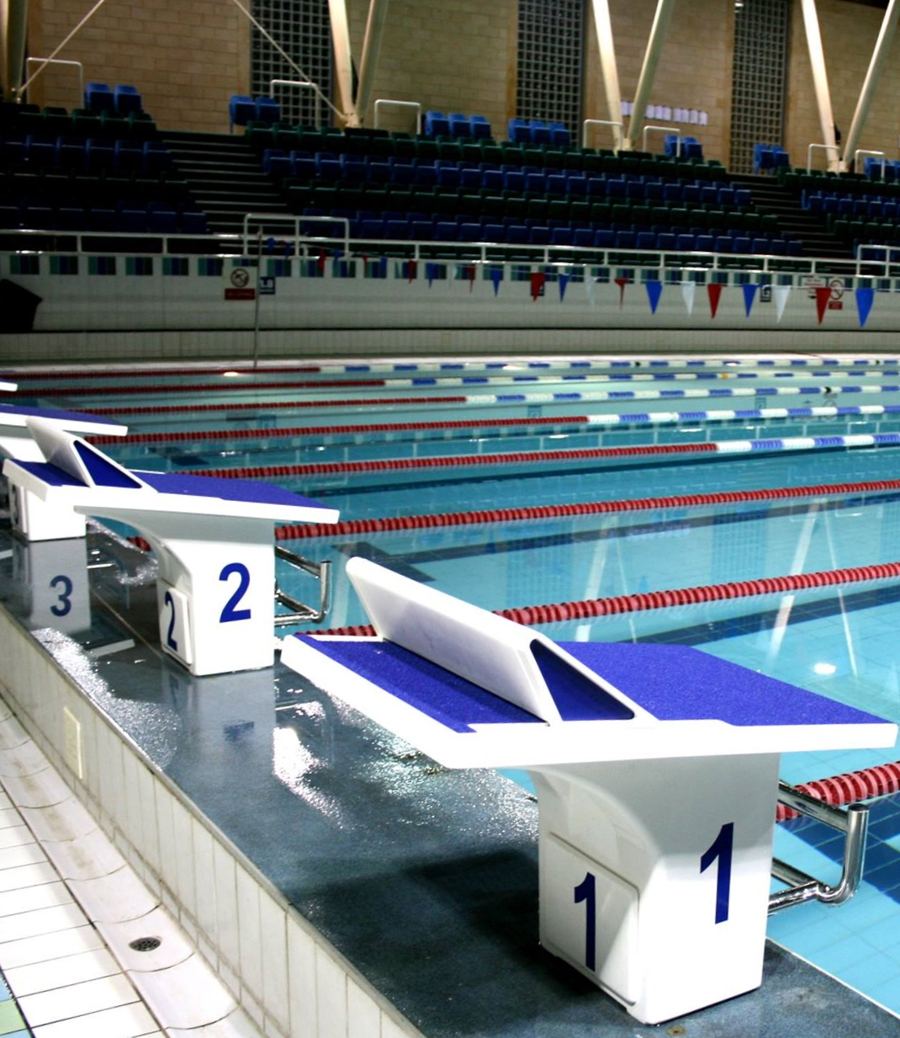
Parkside Swimming Pools, Cambridge.
Cambridge Grand Prix
Cambridge L2 Regional
Short Course Qualifier
Level 2 No. 2ER181257
28th, 29th & 30th September, 2018

City of Cambridge Swimming Club - Cambridge Grand Prix

Cambridge L2 Regional Short Course Qualifier (License Number: 2ER181257)

Friday 28th, Saturday 29th and Sunday 30th September, 2018
Under ASA Laws & Technical Rules: Affiliated to the East Region ASA

Venue: Parkside Swimming Pool, Gonville Place, Cambridge, CB1 1LY

Pool: 8 lane, 25m pool, electronic timing, Olympic-standard blocks, backstroke starting ledges

Age Groups: 10, 11, 12, 13, 14, 15, 16 and over.
Awards: Medals awarded to top three in each age group
Cash prizes: Top Visiting Club – £500
Top male/female 10, 11, 12, 13, 14, 15 and 16+ swimmers – £25 each
Meet record breakers – £25
Spot prizes for randomly selected heats

Events: 50m, 100m and 200m all strokes, 400m freestyle, 200m and 400m IM
Events will run fastest to slowest

Finals: 50m and 100m all strokes

Fees Race Entry Fee: £7.00 per event
Spectator Entry £4.00 per session or £10.00 all day

Entries to Open Meets Secretary, c/o City of Cambridge Swimming Club,
Parkside Pools, Gonville Place, Cambridge, CB1 1LY

Closing Date: 12.00 Midnight on 6th August, 2018

Enquiries can be e-mailed to meets@cocsc.org.uk

Meet Programme
Session 1 – Friday 28th September
Warm-up 6.15pm – Start 7.15pm
 | Event 101  Event 102 |  |  |  | 200 Freestyle  200 Freestyle |  | Female  Male
 | Session 2 – Saturday 29th September  Warm-up 8am – Start 9am |  |  |  |  | Session 5 – Sunday 30th September  Warm-up 8am – Start 9am
 | Event 201  Event 202 | 400 IM  400 Freestyle |  | Male  Female |  | Event 501  Event 502 |  | 400 IM  400 Freestyle | Female  Male
 | Session 3 – Saturday 29th September  Warm-up tbc – Start tbc |  |  |  |  | Session 6 – Sunday 30th September  Warm-up tbc – Start tbc
 | Event 301  Event 302  Event 303  Event 304  Event 305  Event 306 | 100 Freestyle  200 Backstroke  200 Butterfly  100 Butterfly  50 Backstroke  50 Breaststroke |  | Male  Female  Male  Female  Male  Female |  | Event 601  Event 602  Event 603  Event 604  Event 605  Event 606 |  | 100 Freestyle  200 Backstroke  200 Butterfly  100 Butterfly  50 Backstroke  50 Breaststroke | Female  Male  Female  Male  Female  Male
 | 15 minute break before Finals  Session 3 Finals |  |  |  |  | 15 minute break before Finals  Session 6 Finals
 | Event 307  Event 308  Event 309  Event 310  Event 311  Event 312  Event 313  Event 314 | 100 Freestyle  100 Freestyle  100 Butterfly  100 Butterfly  50 Backstroke  50 Backstroke  50 Breaststroke  50 Breaststroke |  | Male  Male  Female  Female  Male  Male  Female  Female |  | Event 607  Event 608  Event 609  Event 610  Event 611  Event 612  Event 613  Event 614 |  | 100 Freestyle  100 Freestyle  100 Butterfly  100 Butterfly  50 Backstroke  50 Backstroke  50 Breaststroke  50 Breaststroke | Female  Female  Male  Male  Female  Female  Male  Male
 | Session 4 – Saturday 29th September  Warm-up tbc – Start tbc |  |  |  |  | Session 7 – Sunday 30th September  Warm-up tbc – Start tbc
 | Event 401  Event 402  Event 403  Event 404  Event 405  Event 406 | 200 IM  50 Freestyle  50 Butterfly  100 Backstroke  100 Breaststroke  200 Breaststroke | Male  Female  Male  Female  Male  Female |  |  | Event 701  Event 702  Event 703  Event 704  Event 705  Event 706 |  | 200 IM  50 Freestyle  50 Butterfly  100 Backstroke  100 Breaststroke  200 Breaststroke | Female  Male  Female  Male  Female  Male
 | 15 minute break before Finals  Session 4 Finals |  |  |  |  | 15 minute break before Finals  Session 7 Finals
 | Event 407  Event 408  Event 409  Event 410  Event 411  Event 412  Event 413  Event 414 | 50 Freestyle  50 Freestyle  50 Butterfly  50 Butterfly  100 Backstroke  100 Backstroke  100 Breaststroke  100 Breaststroke | Female  Female  Male  Male  Female  Female  Male  Male |  |  | Event 707  Event 708  Event 709  Event 710  Event 711  Event 712  Event 713  Event 714 |  | 50 Freestyle  50 Freestyle  50 Butterfly  50 Butterfly  100 Backstroke  100 Backstroke  100 Breaststroke  100 Breaststroke | Male  Male  Female  Female  Male  Male  Female  Female

Meet Rules and Information

- This Competition is licensed by the ASA and will be held under ASA Laws and ASA Technical Rules.
- Entrants must be ASA Registered Category 2, belong to an affiliated club and enter in the name of one club only.
- This is not a first come first served meet. The promoter reserves the right to limit entries. Competitors may be rejected if the meet is oversubscribed in order to meet licence time guidelines. Rejections will be made based on seeded entry time and will be undertaken fairly and equitably across all events, age groups and clubs. The slowest swimmers across each age group would be the first to be rejected.
- All entries of three or more swimmers must be made electronically. SportSys entry files are available on request by e-mail meets@cocsc.org.uk or from the club website at www.cocsc.org.uk. There will be an administration charge of £20 for group entries not submitted electronically.
- Entry forms and payment must be received by the Promoters before midnight on the 6th August, 2018 and be fully and correctly completed, or else they may be rejected.
- Swimmers in possession of an ASA Certificate of Swimming Disability or whose ASA membership record details a disability sport class are welcome to enter the competition with a time slower than the lower limit standard. An entry time must be provided.
- The list of accepted and rejected entries will be published on the club website (www.cocsc.org.uk) approximately two weeks prior to the competition. It is the competing club/swimmer’s responsibility to check this list for accuracy and advise immediately of any mistakes or changes that are required.
- Competitors’ ages shall be as at 31st December, 2018.
- 200m and 400m events will be Timed Finals.
- Finals shall be swum for 50m and 100m freestyle, backstroke, breaststroke and butterfly events in the following age groups, 14/Under and 15/Over and will consist of the fastest 8 heat swimmers from each of the age groups defined.
- Medals will be awarded to the top three in each age group in each event based on heat performance. Age groups as follows – 10, 11, 12, 13, 14, 15 and 16+.
- Finals will be medalled separately based purely on the finals result for 14/Under and 15/Over.
- Cash prizes of £25 will be awarded to the overall top male/female swimmers in the following age group categories: 10, 11, 12, 13, 14, 15 and 16+. This is based on the highest accumulated number of FINA points scored, excluding finals.
- Meet record breakers will be awarded a cash prize of £25. Details of current meet record holders will be noted in the programme.
- Spot prizes will be awarded to randomly selected heat winners. A spot prize heat will be identified prior to the start of the race with a ringing bell. All spot prizes will be awarded at the promoter’s discretion.
- Top point scoring visiting club will receive £500 (calculated on points awarded to the top 8 finishers in each age group).
- Swimmers must withdraw from events that they no longer wish to swim. All swimmers informed of having accepted entries will be deemed as competing unless they have informed the promoter that they do not wish to swim.
- Withdrawals should be made via e-mail to meets@cocsc.org.uk by midnight on Wednesday 26th September, 2018 stating the event number, full name, date of birth, entry time and club.
- Any on the day withdrawals must be made by coaches or the club representative one hour prior to the start of the first event in each session. Withdrawal forms will be included in the coach packs, completed forms should be given to the meet promotor or volunteer co-ordinator via the computer desk.
- Swimmers failing to attend the start of a heat without withdrawing will incur a £10 penalty, which must be paid by the swimmer or the club before the swimmer is allowed to participate further in the meet.
- Refunds are not available for withdrawals, other than for medical reasons.
- Any competitor that withdraws on medical grounds will not be able to participate in any events for the remainder of that session.
- The pool length is 25 metres, 8 lanes with anti-wave ropes and electronic timing and the depth of the pool is 1.2m at the shallow end and 1.8m at the deep end.
- Backstroke starting ledges will be available.
- Competitors must report to the marshalling area in a timely manner, normally one event in advance of their own, where they will be given their start order. Any swimmer not reporting may be deemed to have withdrawn from that event.
- All events will be seeded on submitted times and all heats will be spearheaded.
- Events will run fastest to slowest.
- Coaches/Team Managers will be allowed on poolside if wearing a pass.
- Coach Passes are available free of charge for the Friday evening session, or at £12 for Saturday or Sunday which includes a meal at lunchtime, a programme and a full set of results.
- Coaches and Team Managers must be club trained personnel and clubs are asked to maintain the recommended ratio of 1:20 helpers/swimmers. Untrained parents without a DBS check are not allowed poolside.
- Over the top starts may be used at the referees’ discretion.
- The promoters do not accept responsibility for any property.
- For Health and Safety reasons only small rucksack bags will be allowed poolside. Lockers are available with a £1 coin (refundable). Pool staff will remove any large obtrusive bags.
- Limited seating poolside will be available for Coaches and swimmers. No additional seating is permitted.
- No person will be allowed on poolside without a pass.
- There will be no glass items allowed on poolside.
- The promoters reserve the right to refuse admission to any competitor, participant, coach or spectator.
- City of Cambridge Swimming Club uses a computer to manage entries and results. By submitting and accepting entries to the meet consent is hereby given, as required by the Data Protection Act 2018, to the holding of personal information on computer. Personal data handled such as name, club, recorded and entered times may be made public during or after the meet.
- Charges as follows: Race Entry Fees £7.00 per event, Coaches Passes £12.00 per day (except Friday), Spectator fees £4.00 per session or £10.00 per day, Programmes £4.00.
- In accordance with the ASA Child Safety Procedures and Policies all parents or carers of swimmers under the age of 18 who wish to take photographic or video images are requested to focus on their own child as much as reasonably possible and to avoid including other children in those images, particularly if those images are being shared with family and friends through social media platforms. Should you have any concerns about photography or filming at this event then please bring them to the attention of the Meet Promoter, Catherine Pearson.
- Warm up protocol: Strictly no diving during any warm-up sessions, except in the designated sprint lanes, odd lanes will swim clockwise (1, 3, 5, 7) even lanes (2, 4, 6, 8) will swim counter clockwise. All swimmers must leave the water by the side of the pool and not over the timing pads. Coaches should manage the lanes their swimmers are using during the warm up sessions. Guidance will be given by the meet announcer and Warm Up Marshalls. Warm up schedule will be issued to Coaches on arrival.
- Any matter not covered by these conditions will be determined by the Promoter and Referee, subject to ASA Laws, Regulations and the ASA Technical Rules of Racing.

Disability Swimming Conditions
The conditions outlined above shall apply to the Disability Swimming events except where varied by any of the following conditions.
Eligibility
- Swimmers with S1- S15 classifications will be accepted.
- All swimmers must have an internationally authorised classification.
- Competitors must be registered members of the ASA.
- The meet does not have disability consideration times, however the organisers reserve the right to reject swimmers after the closing date if demand exceeds the time available in the galas.
Personal Care Attendants
- Personal care attendants will be permitted for swimmers in all disability classes.
- A swimmer may have both a coach and a personal care attendant present.
Competition Format
- The competition format will be based on disability inclusion within the able-bodied programme. Swimmers will be integrated on a time-banded basis in all events.
- Positions will be determined by each swimmer’s times relative to the world record in their own classification.
- Disability swimmers will be included but not placed within the results for the appropriate age group in the able-bodied competition unless their entry times meet the qualifying times for the able-bodied competition. They will also be included in the Multi Disability results and placed within those results according to their equivalent times.
- Winners of all events will be heat declared.
- Competition to be run under IPC Swimming swim rules.
- An official who holds the qualification of ASA Disability Official will act as a technical advisor in each of the sessions where disability athletes are entered, if available.
Medals
- Medals shall be awarded on a multi-disability basis to 1st, 2nd and 3rd place in each event. Medals shall be awarded following the posting of the results after the relevant event has taken place.
- Placing shall be determined by achieving a time better than or closest to, the equivalent World record relevant to their own classification.

Qualifying Times

Qualification times must have been achieved at licensed meets since the 29th September, 2017, converted to 25m pool if necessary. All entry times will automatically be checked against British Rankings for validity. Entries with NT will be rejected.

If the meet is oversubscribed your entry may be rejected even if you are faster than the qualifying times.

MALE
 | 10yrs | 11yrs | 12yrs | 13yrs | 14yrs | 15yrs | 16+ yrs
50m Free | 39.01 | 36.92 | 34.71 | 32.85 | 31.07 | 29.68 | 28.78
100m Free | 1:26.39 | 1:20.60 | 1:15.70 | 1:11.10 | 1:07.30 | 1:04.60 | 1:02.60
200m Free | 3:04.14 | 2:53.05 | 2:43.05 | 2:33.45 | 2:25.13 | 2:19.39 | 2:14.94
400m Free | 6:23.96 | 5:58.68 | 5:39.08 | 5:20.26 | 5:04.19 | 4:51.55 | 4:42.93
50m Breast | 51.30 | 48.00 | 45.10 | 41.90 | 39.60 | 37.70 | 36.40
100m Breast | 1:50.60 | 1:43.40 | 1:36.90 | 1:30.10 | 1:25.10 | 1:21.00 | 1:18.40
200m Breast | 3:56.61 | 3:40.18 | 3:27.11 | 3:13.35 | 3:02.06 | 2:54.04 | 2:48.99
50m Fly | 43.80 | 41.00 | 38.80 | 36.40 | 34.30 | 32.50 | 31.50
100m Fly | 1:46.25 | 1:30.40 | 1:24.60 | 1:19.10 | 1:14.40 | 1:10.70 | 1:08.80
200m Fly | 3:45.99 | 3:26.13 | 3:14.06 | 3:01.69 | 2:51.29 | 2:41.72 | 2:37.77
50m Back | 45.10 | 42.50 | 40.30 | 37.60 | 35.80 | 33.90 | 32.60
100m Back | 1:35.61 | 1:30.05 | 1:24.77 | 1:19.30 | 1:14.63 | 1:11.14 | 1:08.95
200m Back | 3:24.63 | 3:11.37 | 3:00.77 | 2:49.39 | 2:39.79 | 2:32.76 | 2:28.30
200m IM | 3:21.59 | 3:07.72 | 2:57.46 | 2:47.01 | 2:37.03 | 2:30.29 | 2:26.01
400m IM | 7:35.60 | 6:59.70 | 6:34.30 | 6:12.00 | 5:50.30 | 5:34.60 | 5:25.40

FEMALE
 | 10yrs | 11yrs | 12yrs | 13yrs | 14yrs | 15yrs | 16+ yrs
50m Free | 39.60 | 37.02 | 34.73 | 33.49 | 32.52 | 32.26 | 31.76
100m Free | 1:25.93 | 1:21.30 | 1:15.91 | 1:13.39 | 1:10.54 | 1:09.50 | 1:08.70
200m Free | 3:04.93 | 2:53.65 | 2:43.25 | 2:36.42 | 2:31.97 | 2:28.70 | 2:26.52
400m Free | 6:27.79 | 5:57.60 | 5:36.83 | 5:23.20 | 5:14.38 | 5:07.52 | 5:04.00
50m Breast | 51.70 | 48.30 | 45.40 | 43.20 | 41.80 | 40.80 | 40.30
100m Breast | 1:50.70 | 1:43.50 | 1:37.30 | 1:32.30 | 1:28.70 | 1:27.10 | 1:26.20
200m Breast | 3:57.11 | 3:39.88 | 3:26.71 | 3:16.22 | 3:09.59 | 3:06.02 | 3:03.94
50m Fly | 43.90 | 41.30 | 39.10 | 37.30 | 36.10 | 35.20 | 34.70
100m Fly | 1:53.95 | 1:30.90 | 1:24.90 | 1:21.20 | 1:18.30 | 1:16.90 | 1:15.80
200m Fly | 3:48.80 | 3:28.21 | 3:13.86 | 3:04.39 | 2:57.84 | 2:53.58 | 2:51.39
50m Back | 45.30 | 42.70 | 40.50 | 38.47 | 37.26 | 36.74 | 36.01
100m Back | 1:35.77 | 1:29.63 | 1:24.02 | 1:20.18 | 1:17.82 | 1:15.94 | 1:14.96
200m Back | 3:26.61 | 3:10.58 | 2:59.88 | 2:52.56 | 2:47.51 | 2:43.15 | 2:40.78
200m IM | 3:22.06 | 3:08.00 | 2:56.98 | 2:49.86 | 2:44.44 | 2:41.03 | 2:38.84
400m IM | 7:35.30 | 6:57.30 | 6:32.00 | 6:14.40 | 6:03.10 | 5:55.80 | 5:50.50

Swimmer Entry Form

Please ensure that you eligible to enter a race before completing this form
ENTRY DEADLINE: MIDNIGHT ON 6th August, 2018

First Name |  |  | Surname
Male or Female |  |  | Phone Number
Date of Birth (dd/mm/yy) |  |  | ASA Reg. No
Club
Address
E-mail
Disability Exemption Code | S= |  | SB= | SM=
Age as of 31st Dec, 2018 |  | Yrs. old
Event |  | Time |  | Fee
50m Freestyle
100m Freestyle
200m Freestyle
400m Freestyle
50m Breaststroke
100m Breaststroke
200m Breaststroke
50m Butterfly
100m Butterfly
200m Butterfly
50m Backstroke
100m Backstroke
200m Backstroke
200m Individual Medley
400m Individual Medley
Total @ £7.00 per event
Payment Method (tick and complete): Cheque (payable to COCSC) BACS Ref: Other:
I hereby declare that the above particulars are correct and that I am an eligible competitor in accordance with the laws
of the ASA and will abide by the conditions laid down by the promoters for this competition.
Signature of Competitor: Date:

Coach/Helper Pass Application Form

Club Name:_____________________________________________________________________

Closing date: Midnight on 6th August, 2018

 | Coach/Helper 1 | Coach/Helper 2 | Coach/Helper 3
Full Name:

Position:
(e.g. Coach)
Home Address:

Telephone No:

E-mail Address:

ASA Affiliation Number:
Number of passes EACH DAY @ £12 EACH Total enclosed: £

The above-named person(s) is (are) authorised to hold a pass for this club:

Signed ______________________________________Club Secretary

Coach Passes will not be available on the day. There will be no access to poolside without a pass.

Coach Passes are free of charge for Friday evening, or £12 per day for Saturday or Sunday.

Passes include entry to poolside, programme and results service.

All completed forms to be returned to:
City of Cambridge Swimming Club
Parkside Pools
Gonville Place
Cambridge
CB1 1LY

Please address any questions to meets@cocsc.org.uk

Officials Request Form

We will provide lunch and refreshments for those doing more than one session and payment for expenses incurred in travel and parking will be offered.

Full Name:

Qualification  (tick box applicable): | JL1 | JL2 | JL2S | Referee
Date License Valid To: |  |  | ASA number:
Sessions  Available: | S1
 | S2
 | S3
 | S4
 | S5
 | S6
 | S7
Mobile No:

E-mail Address:

Club:

Swimmer’s Name

Mentor Request | If you are in the middle of training to become an official and require mentoring, please indicate the sessions you are available and use this box to detail the tasks you require mentoring for.

Please complete one form per official and submit with your Club Summary Entry form
or e-mail to meets@cocsc.org.uk

Club Summary Entry Form

Please return this completed form with your entries and a SINGLE cheque* payable to City of Cambridge Swimming Club, and send to Open Meets Secretary, City of Cambridge Swimming Club, Parkside Swimming Pools, Gonville Place, Cambridge, CB1 1LY

Closing date midnight on 6th August, 2018

Club Name:
Contact Name:
Postal Address:
E-mail Address:
Telephone No:
Entry Details:
 |  |  | No of Entries/ Passes | Cost
Swimmers | @ £7.00 per event |  |  | £
Coaches Pass | @ £12 |  |  | £
 |  |  |  | £
 |  |  | TOTAL | £
Payment Method (tick and complete): Cheque BACS* Ref: Other:

* If you wish to pay by BACS please e-mail meets@cocsc.org.uk for details.

Checklist – By the Closing Date of 6th August, 2018 please ensure you have:
E-mailed:  Club Summary Entry Form (this form)  Sportsys Meet Entry File  Sportsys Meet Entry Report  Coach/Helper Forms  Officials Forms  (BACS transfer) | Posted:  Club Summary Entry Form (this form)  Sportsys Entry Report  Coach/Helper Forms  Officials Forms  Cheque (payable to CoCSC)

